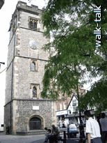
In St Albans, there are trees with fascinating historical connections that span two millennia. This walk takes us round some superb trees and tells the story of each of them.
The walk takes us from the war memorial in St Albans City Centre, through the town centre and down to Verulamium Park.
2 miles at most.

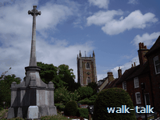
Start from the war memorial in St Peter’s Street on the north side of the roundabout intersection with Catherine Street and Hatfield Road.
Walk towards St Peters church with the memorial gardens on your left
Enter St Peter's churchyard and turn right along the path, leaving the church on your left.
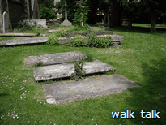
Note the centre grave of three grave stones lying flat on the earth close to the corner of the church. This is the grave of Nathaniel Cotton, an early psychiatrist.
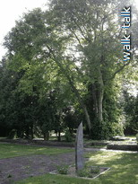

To see the walnut tree (whose half-nuts are brain-like) planted to commemorate Nathaniel Cotton and his work, proceed along the path to the four way path crossing and enter the railed area ahead and to the left. Walk along the path to the left then turn right behind the stone sculpture. The walnut tree has four trunks, soft beige bark, is as tall as a two storey house, and has leaves similar but a bit larger to those of an ash tree.
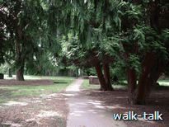

Retrace your steps to the four-path interchange and go straight ahead leaving the church behind and to the right.
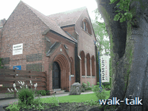
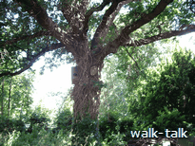
On Hatfield Road, turn left and left again into St Albans Museum. Go through into the gardens behind and see the oak planted in 1899 by Sir John Evans to commemorate the opening of the museum.

Come out of the museum and cross over Hatfield Road at the pedestrian crossing to the left. Turn right and walk the full length of Marlborough Buildings.
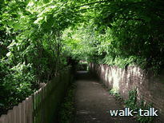
Turn left into a snicket with the Marlborough Building gardens on your left. Zigzag as the path takes you.
When you come out into the open, turn right into the railed gardens and walk through them to the exit diagonally opposite. The dark red brick building ahead is the Council offices.
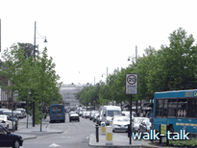
Go right and then left keeping the Council offices on your left. When you are level with the end of the Council offices go right. Pass Barclays Bank to St Peter Street.

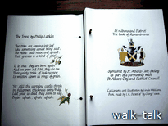
The London Plane trees in St Peter's Street to your right and left and on both sides of the street, were each a gift to the City under a sponsorship scheme organised by the Civic Society in 1999-2003. Many of the trees were planted as commemorations and the Council displays the Society's special illustrated Book of Remembrance which can be seen on the balcony of the space open to the public in the Council Offices you have just passed. The Council's Sustainability Officer maintains the scheme.
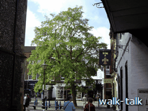
Cross St Peter's Street and go left into Market Place and then along French Row. The tree at the end of French Row is a Robinia and was planted for its French connection: it is named for Jean Robin, herbalist to the King of France in the early 17th Century.

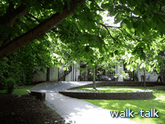
Cross the High Street at the pelican crossing and go into Wax House Gate. As you come to an open green on the left you see a horse chestnut tree that was planted by an Old Contemptible. The tree was grown from a conker from the only tree left standing at the Battle of Verdun.

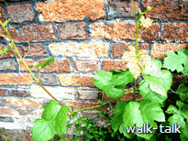
Enter Vintry Gardens, and turn left along the path. You will see a vine growing on the wall on the left. The vine was planted to commemorate the 50th civic exchange between Worms and St Albans in 2007. (A Kaiser Linden tree was also planted to celebrated 50 years of postwar friendship between St A and Worms am Rhein. It was planted in April 2007 in Clarence Park.)

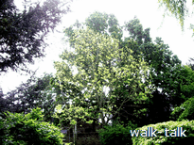
Continue along the path and see ahead the golden ash to commemorate the Year of the Prisoner of Conscience. It was planted in 1976 by Mukhtar Rana, himself a prisoner of conscience.

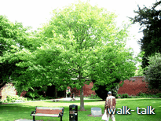

Look over to the oak in the lawn. It was planted to commemorate the local school boys and girls who lost their lives or were injured in a coach crash during a sporting trip to France in 1985.

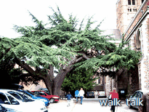

Come out of Vintry Gardens at the lower gate and turn right towards the Abbey. Ahead is the cedar planted by Countess Spencer in 1802 or 1803.

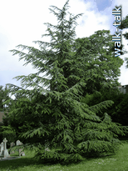
Go to the right leaving the Abbey on your left and turn left at the end of the Abbey into the Abbey churchyard. See the cedar to the right. It was planted by Princess Diana, Countess Spencer’s descendant, when she came to the dedication of the rose window above in the North face of the Abbey.

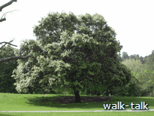
Continue through the churchyard. Go left in front of the West face of the Abbey. Go out into Abbey Orchard and down the path ahead, sloping down the hill diagonally left. At the four-path interchange, see a holm oak, with dark green waxy leaves. It was planted in praise of ecumenism: it is a tree associated with Roman Catholicism planted by a papal nuncio at the invitation of the protestant Abbey.

To the right of the path was planted a pagoda tree by STAND for Hiroshima Day in 1976. The tree gets its name for being often found by temples in Japan. The tree is not there now, but was planted about half way down the hill offset from the path by a few metres.

Another tree is thought to have been planted 'half way down Abbey Orchard': a tree in memory of Elsie Toms, who was a mayor of St Albans and wrote ‘The Story of St Albans’ first published in 1962.

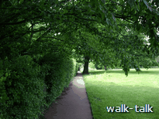
Go left towards the fence bordering the Abbey Orchard and turn right along the path by the fence.

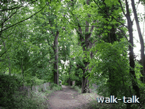
At the end turn left. The avenue of horse chestnuts and limes is called Lady Spencer's walk because it was a favourite route through from the Spencer home in Holywell Hill to Verulamium and the Abbey.

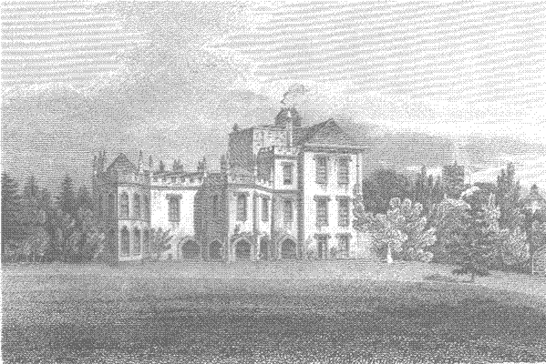
As you come out into Grove Road, go right, then out on to Holywell Hill. Look left up the hill and you will see a blue disk on a wall quite far up the hill on the far side of the road. The disk marks the position of Marlborough House the home of the Spencer family.

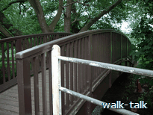
Turn and go right along Holywell Hill and right again over the hump-backed footbridge into Westminster Lodge water meadows.

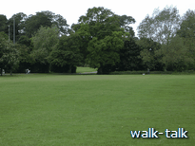

Go diagonally across the water meadow

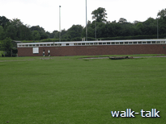

to join a path that leaves the swimming pool and car park and running track on its left.

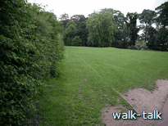

At the far end of the hedge round the running track, go left and up the hill.

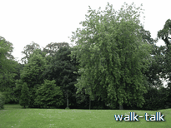

There you will find a circle of North American trees round an oak stump.
These trees were planted to commemorate 75 years since the founding of Rotary International in Chicago in 1905.

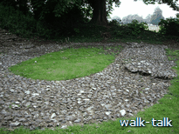
Return to the path and continue into Verulamium Park. Go left to the foundations of Londinium Gate marked out in flint. The triangular temple was through the Gate 200 yards ahead into Verulamium.

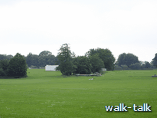
Circuit the railings round the Gate and go diagonally left across the sports pitch ahead (you are walking over the temple) to the end of the line of trees to the right of the Hypocaust (a white building).
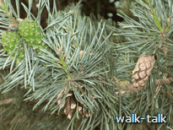

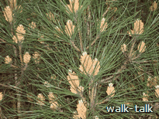
At the end of the line of trees a grove of stone pine (pinus pinea) was planted to commemorate the pine seeds of that tree found in excavations of the temple.

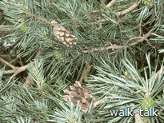

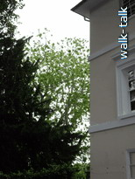
To return to the town centre, go right down the hill to the path. Turn right and, at the end of the hedge, go left. Continue with the lake stretching away to the left, then across a bridge to the Fighting Cocks pub.
Continue up Abbey Mill Lane.
Behind and to the left of the white house on the left, Abbey Gate Office, is a very tall tree.
It is a pagoda tree, not necessarily of the same variety as the pagoda tree planted by STAND but it gives you a feel for the majesty of the type.

Continue under the Abbey Gateway into Romeland. Go right up George Street to the High Street.

Other trees planted for their historical connections include the alternating red and white cherry trees along Sandridge Road by Bernards Heath. The trees were planted for King George V's Jubilee in 1935. They commemorate the Wars of the Roses (red for Lancaster, white for York). The heaviest of the fighting of the Second Battle of St Albans in 1461 was fought on Bernards Heath.

Also planted at Bernards Heath to commemorate the Second Battle of St Albans, is a grove of alder buckthorn. The charcoal of the alder buckthorn was used to make gunpowder. In the Second Battle of St Albans hand guns were used in battle for the first time in Europe. I cannot find any alder buckthorn on the Heath and would be glad to hear from anyone who knows exactly where it was planted and if the trees have survived.

At Batchwood are at least three trees with historical connections: the London plane to commemorate the centenary of Lord Grimthorpe who designed the workings of the Westminster Clock; a tulip tree to commemorate Jim Greening, the last mayor of the City of St Albans as a local authority; and a robinia to celebrate Roma Mills' first mayoralty of the new millennium.

The recently outgone Mayor, Cllr Alison Steer, gave two trees as her parting gift to the city. They were planted earlier this year, one in Clarence Park and one in Rothamsted Park.

During her term of office, 200-2001, Roma Mills planted a tree in Clarence Park for the first Holocaust Commemoration Day.,

Jersey Farm Woodland Park commemorates the Burma Star Association. Bill Morris was responsible for its conception.

It was Paul Arnold, who planted or advised on the planting of trees for their historical connections. It is a wonderful, life enhancing gift to have given the City. It seemed tragic that the story of his trees was not known and I am indebted to Paul for taking the time to sit and tell me about each of them.
I am indebted, also, to
- members of the Civic Society, Peter Trevelyan, Marion Hammant and, particularly, Eric Roberts, for telling me about the tree sponsorship scheme.

- Lady Mayor Kate Morris for corrections, pointers to sources of information and suggesting more plantings to be included.

- members of staff, past and present, of the Museum of St Albans and Verulamium Museum for sources of information.
If you know something about the trees described, or about any other trees that more ought to be known about, please share your information by emailing me, Kate Bretherton, at kate@walk-talk.co.uk

