Collegium Insanorum

Elsie Toms tells us that,
“Another member [of the Independent Chapel in Spicer Street] was Nathaniel Cotton, who carried on a college for the insane in Spicer Street on a site now largely covered by College Street, which was cut when Verulam Road, part of Telford’s Holyhead Road, was constructed.” (Elsie Toms (1962) ‘The Story of St Albans’, Revised Edition 1975, p113)

The re-construction project of the Holyhead Road overseen by Thomas Telford commenced in 1794 (Ibid p125). Elsie Toms again:
“There is a most interesting map of the central part of the town, dated 1827, showing the line of the new Verulam Road, not yet named but called the New Road, and College Street, called New Street….The New Street cut off the wings of the College, which is shown [on the 1827 map] as a long house with forward-projecting wings on north and south, the greater part of the wings is shaded as covered by the road. In my childhood the house had the remains of the wings projecting only a few feet and gabled, but this map explains the difficulty.” (Ibid. p146)
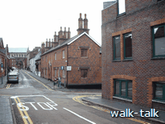
This photograph is taken in College Street looking, across Lower Dagnall Street into Spicer Street and down towards the Abbey. From Elsie Toms description above, the Collegium Insanorum must have been partly across College Street – across the STOP sign painted on the road – and partly into the new building in the foreground on the right.

Here is a reproduction of a slide in the St Albans Local History Section of the Hertfordshire Library Service collection. It is labelled:
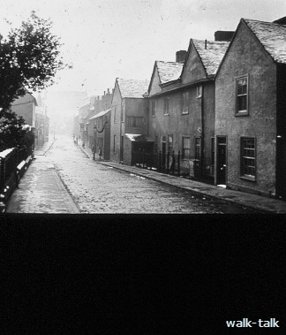
“College Street: view looking South and into Spicer Street. Abbey roofline visible (pitched roof); on right of the picture is the remains of the “College Insanorum” of Dr Nathaniel Cotton. C 1910 Photo E.S. Kent.”

It is difficult in the reproduction to see the Abbey at the far end of College Street – as you can looking at the slide under a magnifying glass and as you can in my photograph - but the Abbey gives us a marker and confirms that the two photographs are taken in the same direction, my photo being from a bit nearer Spicer Street.
We can see the slightly projecting gabled vestigial remains of the wings of the college.

From all this, it seems that the further wing must have been across the top of Spicer Street with the entrance to the College on the far side. Elsie Toms mentions Lower Dagnall Street as being in the 1827 map so presumably the entrance to the College was in Lower Dagnall Street. This is surprising in view of Elsie Toms’ statement (quoted above) that the College was in Spicer Street. It would have been more obvious to say either that it was across the top of Spicer Street or that it was in Lower Dagnall Street. Do we assume we cannot see the west part of Lower Dagnall Street in the 1910 slide because it is hidden behind the far (south) vestigial wing of the College? Or did Lower Dagnall Street only run from Verulam Road to Spicer Street? I shall ask at the Museum to see the 1827 map and keep you posted.

Nathaniel Cotton died in 1788. I have no information as to whether the asylum continued after his death. The earliest St Albans Almanac in the St Albans Hertfordshire Library is dated 1882, a whole century later. Names of residents are listed but not the number of the house in which they lived. One entry under College Street is “Blow, Miss C.H. College-House School”. This might indicate that Miss Blow ran a school at what was left of the College Insanorum.

Elsie Toms says that
“the remains [of the College] were standing in the early years of this century. It was pulled down later and a shoe factory rose in its place.” (Ibid p113)

Workers in the offices on the corner of Lower Dagnall and College Streets can be content to know that although the present smart building in which they work stands on the ground of an asylum, the inmates were treated in the most enlightened and happy way and that conditions in the shoe factory would have been happier than those in the previous century endured by Charles Dickens in the shoe-blacking factory he worked in for a time as a child.

