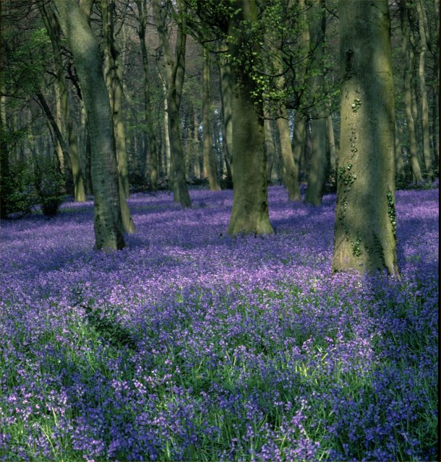

A carpet of bluebells in a hushed woodland is an icon of English countryside beauty.

There are great sweeps of bluebells in the ancient woodland of Bricket Wood Common.

This walk takes us across parkland and then into the Common among masses of bluebells, up through a hillside of bluebells to views across the Lea Valley, down to the confluence of the Ver and the Colne, across water meadows and farm lands, close to a stately home framed by cedars of Lebanon and by a house with a myriad of terracotta depictions of 19th Century sporting pursuits.

By contributing our observations of bluebells, we can help to find out the extent to which the cultivated Spanish bluebells in our gardens are ousting native English bluebells. See http://www.nhm.ac.uk/nature-online/british-natural-history/survey-bluebells/bluebells-exploring-british-wildlife.html.

A questionnaire on which to record your observations will be sent to you if you log your postcode at http://www.nhm.ac.uk/nature-online/british-natural-history/survey-bluebells/recording/recording-your-bluebells-map.html.


Our native English bluebell

This walk is in the form of a figure of eight that crosses and re-crosses School Lane, twice giving us the opportunity to cut the walk short and return to the pub.

The whole walk is 3.5 miles but can be shortened to 1.75 miles.

Bricket Wood is close to the river Colne and is inclined to be wet. Waterproof footwear is advisable especially after rain.

The walk starts at The Old Fox, School Lane, Bricket Wood, St Albans, Hertfordshire, AL2 3XU, TL 127002, Tel: 01923 673083.

One way to get to The Old Fox from St Albans is to leave town by going down Holywell Hill, up St Stephens Hill and straight on through Chiswell Green. At The Noke roundabout, go straight on towards the M1 and M25.

Go straight across the M25 roundabout, keep in the left hand lane, turn left as if going on to the M1 but turn left into Mount Pleasant Lane before you find yourself on the M1 slip road proper.

Continue on Mount Pleasant Lane, go under the railway bridge and turn immediately right into School Lane. The Old Fox is at the end of School Lane.

Map

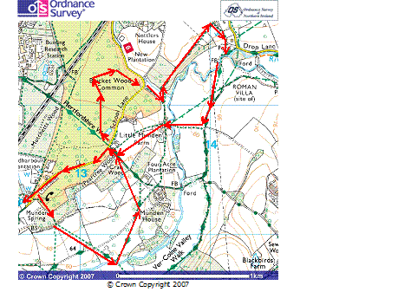

This mapping data licensed from Ordnance Survey® © Crown copyright 2007.
All rights reserved, licence number 100046670.

The blue jug handle just visible two-thirds down on the left represents the Old Fox pub, the start of the walk.

The red arrows mark the route of the walk. It is possible to cut the walk short by walking back to the pub along School Lane as the points the walk crosses it.

The Old Fox to School Lane at the drive to Munden House

TL 127002 to TL 132007

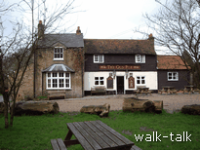
The Old Fox
TL 127002

With our backs to The Old Fox, and with the telephone kiosk in front of us, we go about 20 steps to the left and turn right on to a footpath.
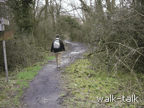
Footpath 20yards from the telephone
TL 127002

After rain it is bound to be muddy here and there is nothing for it but to be prepared and wear stout boots or wellies.

We soon see a few bluebells on the right. There might be a danger of losing our native English bluebells to a hybrid with the Spanish bluebells cultivated in our gardens. We take a minute to note which ones they are and where we found them. Here the grid reference is TL 127 002.

Remember, English bluebell leaves are narrow (9-13mm), flowers hang to one side of the spike, flowers are narrow with straight sided bells, petals are narrow (3-4mm), and anthers are creamy white.

Spanish and hybrid bluebell leaves are broader (19-27mm), flowers are on both sides of the spike which does not hang to one side, flowers are flared open bells, petals are broader (5-7mm), anthers are pale to dark blue.

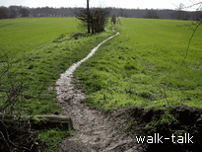
We come out of woodland and step over a couple of logs set into the mud.
Raised path between fields
TL 128001

We carry straight on between fields that are often waterlogged but we are on a path raised a bit above the level of the fields so that the going is relatively dry and easy.

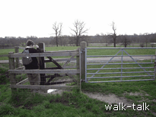
There is a gate at the end of the field. Note the rope to keep the gate closed. Do replace the loop round the post.

Gate on to asphalt drive
TQ 129998

We go left along the asphalt.

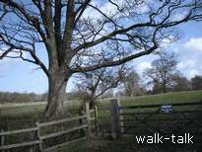

We come to a cattle grid or, I suppose in this case, a sheep grid, that we can tiptoe over, or we can use the gate to the left of the wide gate.

Gate to the left of the sheep grid
TQ131999

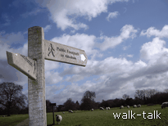
Through the grid and gate we bear right upwards on to a grass footpath.

Footpath sign directing us right, on to a grassy path
TQ 131999

There is a good footpath sign to direct us (and the road ahead does have a clear sign saying that it is a private road). It leads to Munden House.

The path is clear although the grass is not worn through.

Over the mound, we aim for the bridge over the river ahead. We do not want to go over the bridge but to turn half left in front of the bridge and go back up and over the mound again, this time to the right of the trees and bushes that were on our left as we came down.
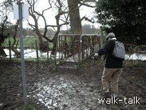
If the approach to the bridge is muddy, curve left short of the quagmire. If it is not too muddy, it is worth going on to the bridge to view the waters of the River Colne.

Approach to the bridge might be too muddy
TQ 133198

When we get back on to the top of the mound, the ground flattens out through parkland. We see the path ahead as darker green grass.

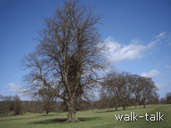
Darker-green path to the right of trees
TQ134999

We are beginning to get glimpses of Munden House ahead of us and to the right beyond spreading cedars.

We soon come out on to the asphalt road that we were on. We cross it, again on to grass worn dark to show our path.
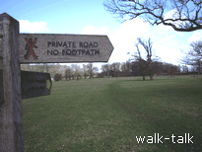
Dark grass shows our path
TL 134001

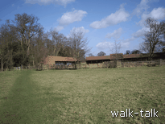
We aim for the left hand end of the buildings ahead. The buildings are used for wood storage and one leg also has stables.

Woodstore and stables ahead
TL 139004

We come through a kissing gate on to a hard-surface road: not concrete or asphalt, but hard surface. We go up the hill to the left.
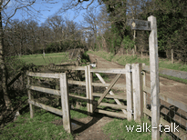

Kissing gate and hard-surface road up the hill
TL 139004

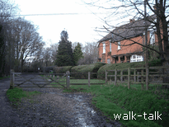

Over a cattle grid, we come level with a brick house with a moulded brick tile at first floor level “AHH1902”.

Brick House
TL132007

From School Lane at the drive to Munden House, through the bluebell woods to School Lane at the drive to Little Munden Farm

TL 132007 to TL 135016

We come out on to School Lane.
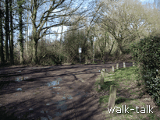

The hard-surface road comes out on to School Lane
TL 132007

Straight ahead is a bridleway. The entrance to the bridleway is often more like a lake than an inviting path so that we go a bit to the right along School Lane.
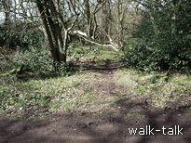
Before we reach a brick house on the right with palings and laurels around it, we go left into the woods on an obvious path between holly saplings.

An obvious path between holly saplings
TL 133007

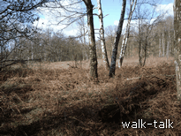

We curve round to the right as we come out into a more open area with silver birches.

Open area with silver birches
TL 132007

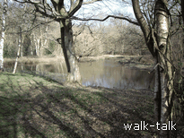
There is a pond on the right.

A pond on our right
TL132007

We skirt the pond then follow the path as it winds through the silver birches.
Here we see a small but clear yellow bar painted on a tree ahead and we are reassured that this is a designated path.
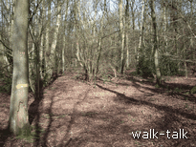

Yellow waymark painted on a tree
TL 132009
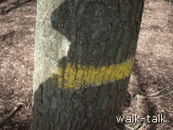

Immediately we see another yellow horizontal bar on a tree to the right.

The path is clear from now on and there is always a white or yellow or orange mark in sight to guide us.
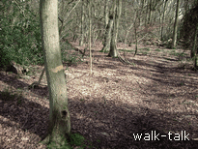
A yellow waymark

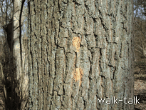

An orange waymark

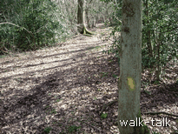

Another yellow waymark

The path meanders, the leafmould underfoot keeping it from being too soggy.

Soon, to either side, we see the bluebells we have come to see.

Generally, we are heading northeast parallel to School Lane. Eventually we shall come out again on to it.

We come down to a streamlet. The yellow dot on the one side of the streamlet is some way, about 30 yards, from the dot on the far side.
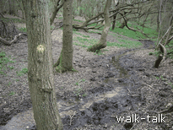
Yellow dot on the tree on the near side of the stream

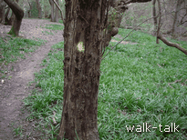

Yellow dot on the tree on the far side of the stream

After wet weather, it is a case of looking for the best crossing on the day. I curled myself round the tree with the yellow dot on the nearside and stepped easily over the water. It was a bit soggy on the other side but, by going upwards, I was immediately out of it.

There are two clear arrows each on trees ahead, making doubly sure we know we can go left – if we want to.

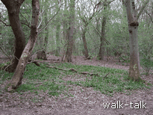
Two clear arrows pointing left
TL 134012

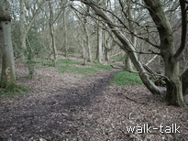
If we want to go more directly on to School Lane, we follow the yellow dots ahead and to the right.

Straight ahead to School Lane
TL 134012

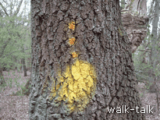

If, however, we want more bluebells, we follow the arrows left for a loop through more bluebells. The first waymark is a yellow dot with three orange dots above it.

A yellow dot with 3 orange spots above it
TL 134012

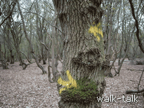
We come to a tree with an arrow pointing right and also an arrow pointing back towards us.

Arrows pointing right and towards us

Here we go right.

A stump with a horizontal bar confirms our decision.
Honeysuckle and lichen on the oak bark, together make the next dot difficult to see. It is pale yellow and has four orange spots above it.

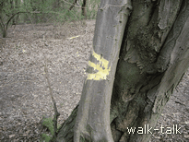
Look out for an arrow pointing right. It is on a secondary trunk curling up the main trunk, the paint running down a bit from the arrow.

Arrow on a secondary trunk

We shall NOT go right in the direction of the arrow, but GO LEFT on a clear path towards a tree with a bright yellow dot.
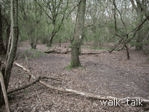

Bright yellow dot

The path is clear and so are the marks on the trees. There is not much in the way of bluebells at first but then there are great sweeps of them on the right.

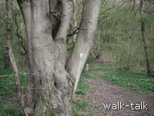
We start to come down into a valley and see a mark on a particularly large tree, a beech.

A beech tree on the path down

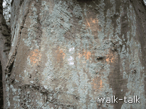
We climb down to the bottom and then up again to where a path comes in from the left at a tree with orange spots on it. The spots are in the shape of a cross: 4 along the horizontal, and a spot above and below.

A cross of orange spots
Here we go left.

(If we were to go straight ahead we would walk through the coppiced hornbeams with no ground cover beneath them and come out at the top of School Lane near Station Road.)
Almost immediately on the right is a grassy bank with tiny wild flowers, wood sorrel (Oxalis acetosella), to the side and beyond it. It is an exquisite little glade.
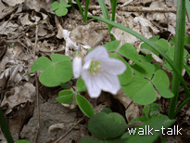

Wood sorrel by a grassy bank

Each flower is the palest pink with delicate mauve veins and tiny anthers nestling down in the centre of the petals. They have a trefoil clover-like leaf.

Our path ahead is clear but there are no waymarks. About 20 yards ahead, we come to a path down to the left. We go left.
(If we were to go ahead we would come to some interesting banks and ditches and a path with cream waymarks. I went this way for a bit and heard and then saw a greater spotted woodpecker on a dead tree. The sharp contrast of its black and white wings and bright red lower belly made it spectacular. There are no bluebells in this direction.)

The path left takes us down into the valley. There are no waymarks but the path is clear. There are hawthorns and holly and oaks. Ignore a path to the right. The path has curved so that we are walking parallel to the valley, now on our left.

We come up to a clear path left and right. We go right. (If we were to go left we would come to the beech tree before the valley.)

There is an oak on the left of the junction, three deeply grooved hornbeams ahead.
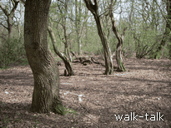
Oak and three grooved hornbeams

We go right, leaving on our left a tree with a yellow dot and a u-shaped hornbeam, and on our right a curved hornbeam and then a slim-trunked oak.

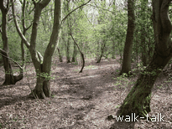

Yellow dot, u-shaped hornbeam, curved hornbeam and slim-trunked oak

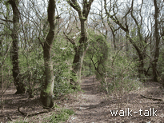

At one point the path divides. We keep left under a bower of honeysuckle supported by a arched hornbeam.

Bower of honeysuckle

We come again to our arrow on a secondary trunk.
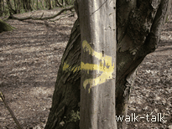
Arrow on a secondary trunk.

We carry straight on.

There is a dip on a left covered in bluebells and then, on our right, almost an amphitheatre of bluebells.

We go steeply up to a T-junction of paths.

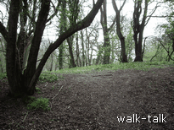

Up to a T-junction of paths
TL 134012

We go left and come down on to School Lane.

From School Lane at the drive to Little Munden Farm, up to the confluence of Ver and Colne, and back to School Lane at the drive to Munden House

TL 135012 to TL 132007

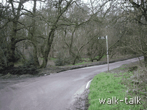
At School Lane, if we have had enough we can head right along School Lane back to the pub.

School Lane
TL 135012

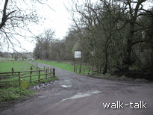
To take us on a leg stretcher of about an extra 1¾ miles (2.5 km) with a magnificent bank of bluebells and some good long views, we head down the farm road almost opposite us, leaving on our right the white sign “Little Munden Farm, Munden, Watford, Herts” and “ McLelland Horse Feeds”.

Farm road to Little Munden Farm
TL 135012
We can see a few bluebells on the right. They are between great gouged-out pits. I wonder whether clay was taken from them to make bricks. Across the meadow to the left we can see bluebells in a sweep up the hill. We shall go up through them.

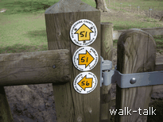
Before – about 50 yards before - we get to the silver gate across the road ahead of us, we go through a kissing gate on the left.

Waymarks on the kissing gate
TL136011

We want “Footpath 51”.

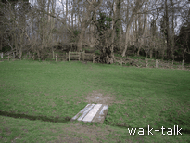

We aim for the bridge across the stream and then for the kissing gate into the woodland ahead.

Bridge across the stream and kissing gate beyond
TL131011

There are good steps made with wooden planks for the risings. There is some slippery, difficult mud as we get towards the top of the hill. But not for long and the woodland is lovely and the bluebells are terrific.
We come out into some younger woodland. There is oak, cherry, beech and ash amongst the new planting.

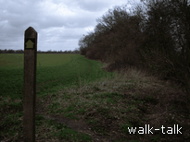
In due course we come out into open country.

Path ahead as we come out into open country
TL137013

There is a bank to the right, covered in bluebells, sloping steeply down to the river. We go straight ahead keeping to the direction we were heading through the woodland.

It is worth pausing to look over our left shoulders at the long view behind us over the top of the trees. Even the pylons add to the composition of the picture.

At the end of the meadow we are traversing, we go to the left of a hedge.

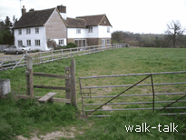
As we draw level with the house ahead, there is a stile on our right to the left of a metal gate.

Stile in front of the house
TL140016

We go over the stile and walk across the front of the house. As the fence in front of the house bears off to the left, we carry straight on.

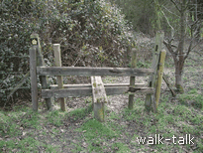
We are aiming for a stile beyond a pair of oaks ahead.

Stile beyond a pair of good oak trees
TL141016

There are long views here across the Lee Valley.

Over the stile we curve right and then left and go down a bank.

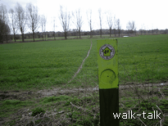
We can see ahead the path we want leading across a field to a line of poplars and the river.

The path to a line of poplars
TL 141015

Where we come up to the river, immediately to our left, is where two rivers flow into each other.
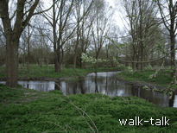
The confluence of the Ver and Colne

Strictly, the Ver is coming in to the Colne because from here on, down south and west through Rickmansworth and Watford, the river is called the Colne.

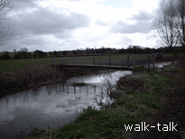
At the river we go right. Only the waymark pointing left remains on the post but we can see where the circle of the waymark pointing right used to be on the post. From where we are we can see about 50 yards ahead of us the bridge we want to take to cross the river.

The bridge to our right
TL 141013

On the far side of the bridge, we take the clear path curving ahead and to the right so that we are heading south.
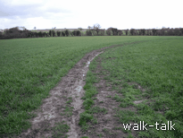
Clear path curving ahead and to the right
TL141012

As the path straightens out heading south, we arrive at a broad track named Common Meadow Lane. There is a redundant stile but no sign of the lane name.
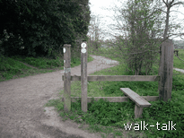

The entrance to Common Meadow Lane
TL140010

We head south along the Lane until we turn right along the track leading into Little Munden Farm with its large white sign on the right and heaps of compost on the left.
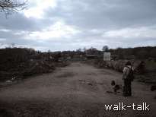
Track into Little Munden Farm
TL 140008

We are on a wide farm track. There is a gate that is usually open but if it is not there is a gap alongside.

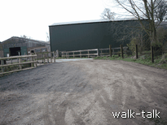
We come up to the left of a green barn and cross the river on a good bridge.

Green barn and bridge
TL137008

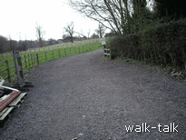
At the end of the green barn, we go left along a gravelled track.

Gravel track
TL13708

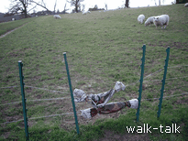
There is sometimes an electric fence across the track. Look for the plastic-covered dip in the fence, usually a bit off the line of the path, and step over the fence carefully.

Plastic coverings over the electric fence
TL 137007

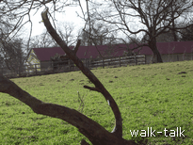

Ahead and to our right is the back of the woodstore and stables.

Back of the woodstore and stables
TL136005

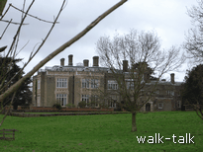
Ahead is Munden House.

Munden House
TL136003

We come out at a wide gate and a small gate.

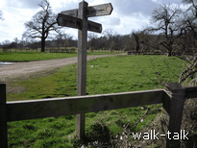
We turn right up the track.

The track to the right.
TL 136004.

The wood store and stables are on our right.

As we level with the stables and the road curves right, we see the footpath we came in on at the beginning of our walk. We could retrace those steps through the parkland if we want to, but my plan is to go up to School Lane and along it to The Old Fox. We continue on the track, then – we did this short bit before - up to School Lane.

From School Lane at the drive to Munden House, to The Old Fox

TL 132007 to TL 127002

At School Lane we turn left.

The woods and houses and gardens are pleasing and this end of School Lane tends to be quiet because there is only the pub and a few houses ahead.

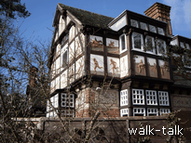
Shortly before we reach The Old Fox, we pass on our right the amazing Picture House.

The Picture House
TL 123009

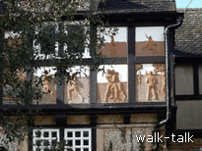

In terracotta all over the upper elevations are depictions of 19th Century sporting activities.

Terracotta depictions of sporting activities
TL 123009

And now we are back at The Old Fox.

