
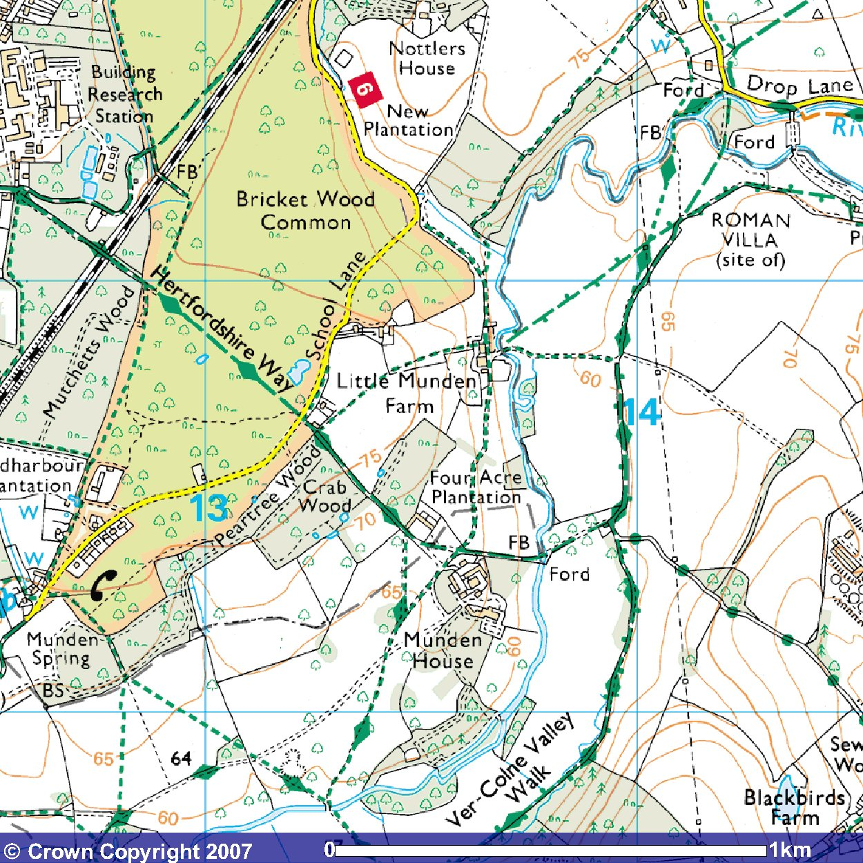
© Crown Copyright 2007
www.ordnancesurvey.co.uk/getamap
Image produced from Ordnance Survey's Get-a-map service.
Image reproduced with permission of Ordnance Survey and
Ordnance Survey of Northern Ireland.

This mapping data licensed from Ordnance Survey® © Crown copyright 2007.
All rights reserved, licence number 100046670.

The blue jug handle just visible two-thirds down on the left represents the Old Fox pub, the start of the walk.

The red arrows mark the route of the walk.

It is possible to cut the walk short by walking back to the pub along School Lane as the points the walk crosses it.

