Wild daffodils are smaller and paler than cultivated ones. It makes them seem more vulnerable and all the more precious. We are lucky to have quite a spread of them in a pretty, woodland setting within easy distance of St Albans. The daffodils have been there every year that I can remember. I dare to hope that they will be there for our joy this year.

The walk is 3 ¼ miles long. Unless it is frosty so that the ground is hard, there will be muddy patches.

Start from The Brocket Arms pub (TL 196169) in Ayot St Lawrence.

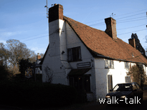
Brocket Arms
TL196169

To get there from St Albans, we go out of town on Sandridge Road, through Sandridge and Wheathampstead to the roundabout at the north end of Wheathampstead where we go right on Codicote Road, the B653. We take the first left, still Codicote Road, and then left again into Bride Hall Lane. We pass Bride Hall on the left and then Shaw’s Corner, also on the left. When we see a ruined church on our left, we park there on the road. The Brocket Arms is a bit further up on our right. The pub does good food and has a good range of traditional beers.

Brocket Arms to Bibbs Hall Lane at Prior’s Wood

TL 196169 to 188169

With our back to the pub, we go right, along the road. At the first corner we see footpath and bridleway signs on a post on the right. Both are pointing left, the footpath sign saying “Codicote Bottom 1 ¼”
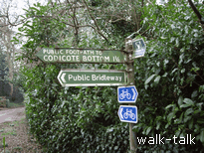
Signs on a post on the right
TL 197169

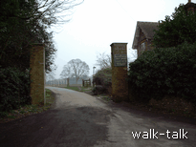

We follow their direction up an asphalt drive brick between brick pillars.

Brick pillars
TL 197169

On the right hand pillar is a green board with “Manor House” and other information and instructions on it.
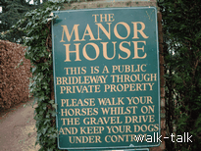
Green board on the right-hand pillar
TL 197169

Do not be tempted by the footpath sign on the right immediately after the lodge house at the entrance. Keep on the asphalt drive.

We keep on the drive with the beech hedge on our left and occasional shrubs on the right with parkland behind it.
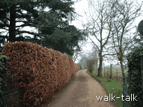
The drive with beech hedges on the left
TL 197170

On our left we pass the elegant gates of the Manor House.

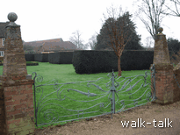
Gates on the left
TL 197172

The beech hedges curve in on our left but we keep straight on along a wide track with an orchard and paddock on the left, lined with some superb mature ash trees. There are open fields on the right.

We come to a black barn with a grey-brick low wall in front of it.

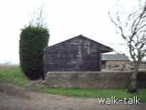

Black barn and grey-brick low wall
TL 195175

We go ahead into the field and turn left under an overhanging ash tree.

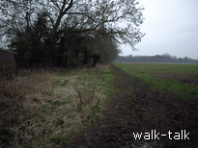
Left under an over-hanging ash
TL 195175

There is a small grey building to the left and the field is on our right with superb views beyond that.

At the end of the field we want to go over the stile.

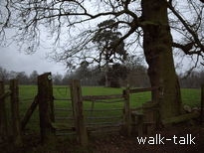

Stile at the end of the field
TL 192173

There are several worn paths across the grass. We aim (south) for the left-hand end of the woods ahead of us.

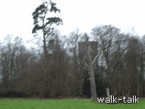
There is a water tower in the woods. We want to be a little beyond it.

Water tower in the woods ahead
TL 190170

Look out for the stile at the left-hand end of the woods and go over it.

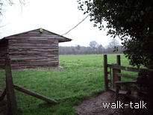
The stile we want
TL 191170

You will know you have the right stile because next to it is a black weather-boarded animal house with a distinctive overhanging roof.

We are confined between a fence on the left and high trees on our right – holly at first – so that there is no mistaking the route.

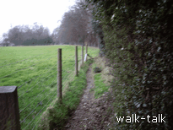
Confined path
TL190171

The water tower is close to our path at the point where we go over another stile.
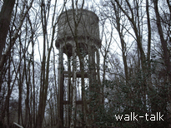

The water tower close by the next stile
TL190170

.

We go over another stile where, on our right, the hornbeam trunks are horizontal from having been laid many years ago.
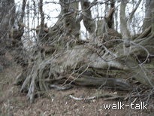
Distorted hornbeams
TL 189169

We see new laying of an old hedge a bit further on. Donato Cinicola did the laying in 2006. He has been Hertfordshire Champion Hedge Layer for several years in succession.

The wood to our right is Prior’s Wood.

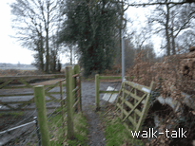
We come over a final stile on to Bibbs Hall Lane.

Bibbs Hall Lane at Prior’s Wood
TL 188169

From Bibbs Hall Lane at Prior’s Wood to the farm-end of the avenue of limes

TL 188169 to 182161

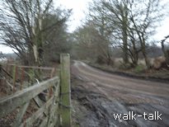
We go left along the asphalt road, Bibbs Hall Lane.

This is a road for vehicle traffic so beware.

Left along Bibbs Hall Lane
TL 188169

We continue on the road until the corner where the road turns left through 90°.
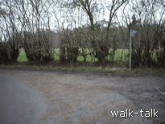
Bibbs Lane corner
TL 188 167

Here we go right. (It looks on the OS map as if it is straight on but it is definitely right of the road at that point.)

We go through the opening to the right of the double wooden gate.

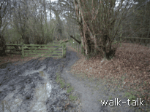
Opening to the right of the double-width gate
TL 188 167

It is quite a wide track at first. It soon curves left (in line with the OS map markings).

It is in these woods on the right that the daffodils grow.

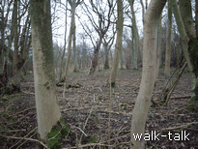
The daffodil woods in February
TL 188 166

The daffodils tend to be a bit further on, away from the road. I have seen deer in these woods too. It is worth standing quietly and looking through to see what you can see.

We come to a four-path crossing. We shall return down the path ahead and go off to what will then be our right.

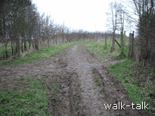
Four-path crossing, looking south
TL188165

Now we go right so that the daffodil wood is still on our right.

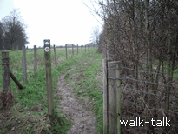
We are confined between two fences.

Confined between fences
TL188165

There is a kink in the path where there is a fence going off to the right. I have never seen daffodils after that so that from here we need to look up and enjoy the wider view.

There is a hedge going across our triangular pasture on the left and there are interesting banks and ditches on our right. Here we go over another stile but there is no doubt about the route because we are still confined between fences.
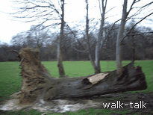

Uprooted ash with vertical branches
182165

Soon after the uprooted ash with vertical branches, we go over a stile into a field.

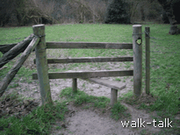
Stile soon after the uprooted ash tree
TL181 165

Over the stile we go left.
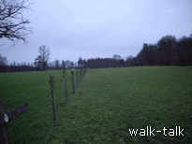

Left-hand fence
TL 181 165

On our right we see the stables of Lamer House, now Lamer Farm house.
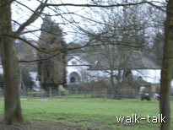

Lamer Farm House
TL 181 163

We hug the left hand fence of the field until we reach a stile at the far end.
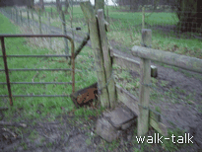

Stile on to the lime avenue
TL 182 161

There is always a quagmire under the tree by the stile but it can be avoided by going right, round the tree. We go over the stile on to a hard surface under an avenue of limes.

We go left into the avenue.

From the farm end of the avenue of limes to The Brocket Arms.

TL 182 161 to 196169

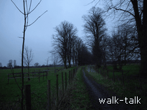
The lime avenue at dusk
TL 183 162

We cross a stile mid way along the avenue.
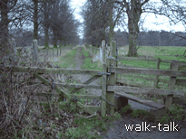

Stile mid way along the avenue
TL 185163

We walk down the avenue to its end, where we come to the four-paths crossing where we went off to what is now our left. The corner of the daffodil wood is ahead of us on the left.

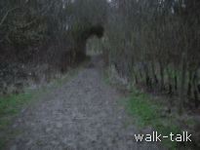
We go right.

Right at the four-paths crossing
TL 188 165

There is woodland on our right and a row of trees on the left beyond which is the grass around the large cream house.

A bit beyond the cream house there is a flight of wooden steps with a hand rail. We ignore the wooden steps and go straight on until we come out on to an asphalt road, Bride Hall Lane. We go left, being careful because it is a road for vehicles.

We pass Shaw’s Corner on our left and, further on, also on our left, a Gilbert-Scott red telephone box. We follow the road to the right by Ruins Cottage and pass the ruins of the Old Church with its gate depicting two figures, a deer and birds.

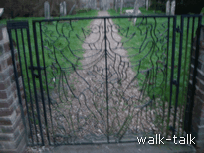
The gate to the ruined church
TL 195168

The Brocket Arms is ahead on the right.

