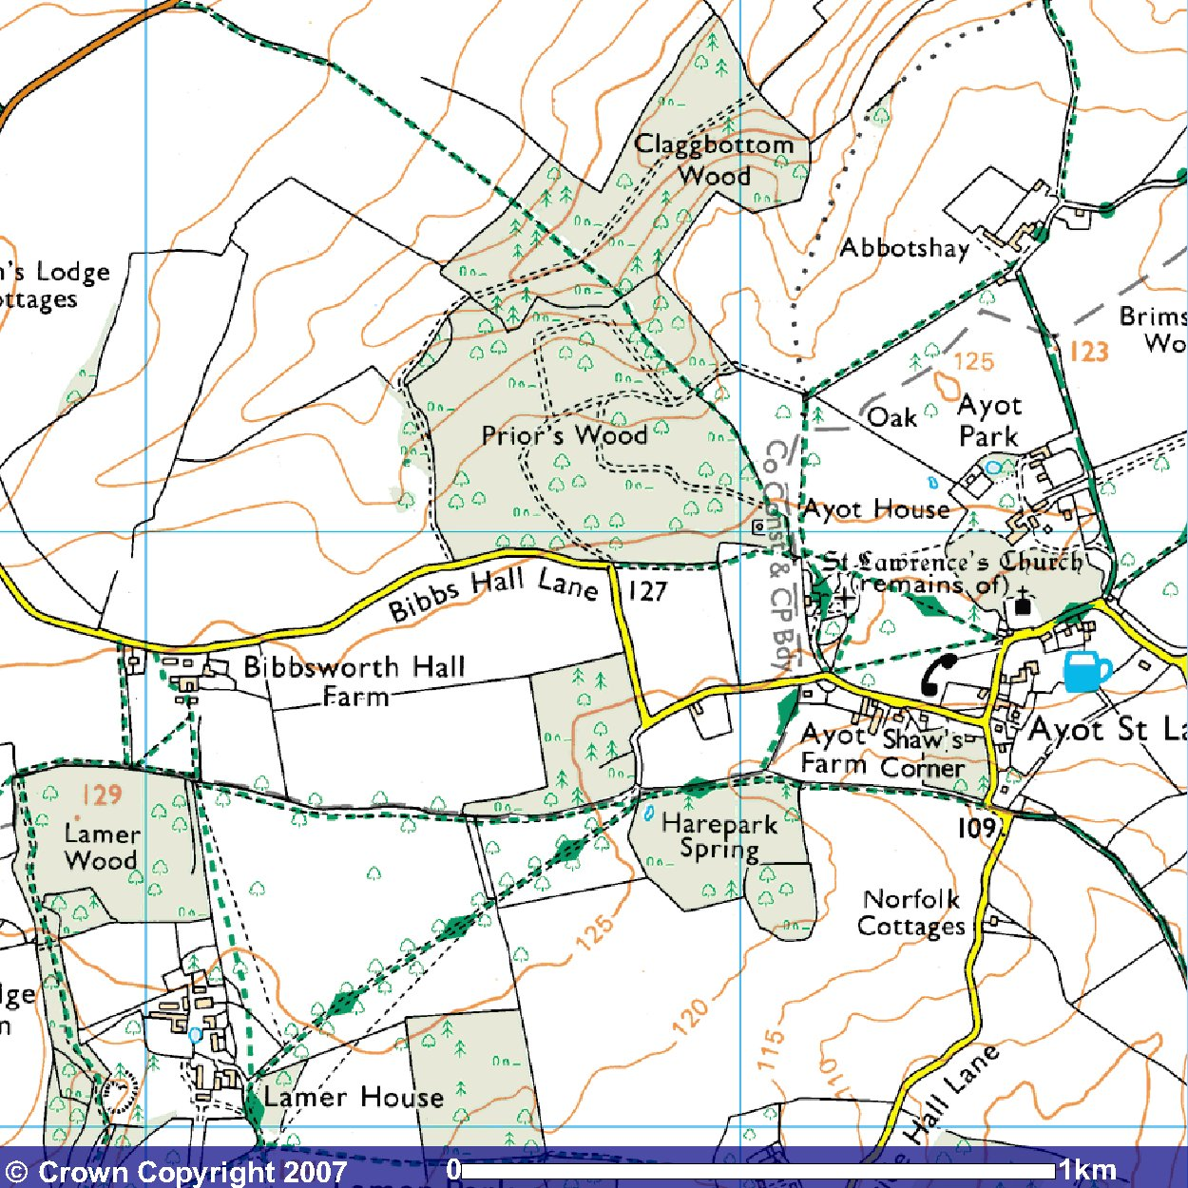

This mapping data licensed from Ordnance Survey® © Crown copyright 2007. All rights reserved, licence number 100046670

The jug, mid right, represents The Brocket Arms pub, the start of the walk.
For the walk, follow the red arrows.

The green diamonds along the avenue and on, represent part of Hertfordshire Way only some of which is included in the Snowdrop Walk.
.

