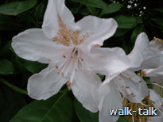
This is a good walk, right in St Albans but with lots of parking for which there is no charge. Ancient woodland, interesting houses, a magnificent drive way, working countryside and long views make it a gem.

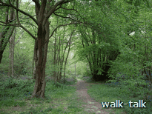
The Golf and Tennis Centre has a café where you can get a hot or cold drink and a sandwich and either sit at a table inside or on a bench outside to enjoy it.

The walk circuits historic
Batchwood Hall, meanders
through the home wood and
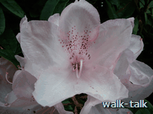
then across the golf
course into Batch Wood,

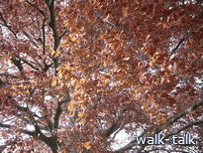
across a field and through a fruit farm to Childwick,

along the rhododendron-lined drive

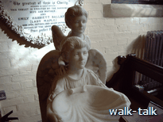

by St Mary’s church

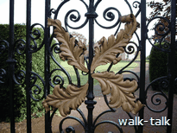

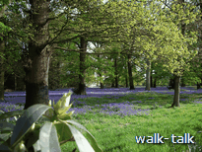

to the manor where Stanley Kubrick lived

and on back to Batchwood by the Childwickbury Goat Farm and Lady Grove taking in good long views across the Ver valley.

The start is at Batchwood Hall, Batchwood Drive, St Albans, AL3 5XA. NGR: TL 137088.

To get to the start of the walk from St Peters Street in St Albans, leave the Town Hall behind you, cross the Catherine Street/Hatfield Road roundabout and keep on into Harpenden Road. At the traffic lights, turn left into Batchwood Drive and, immediately after the first road to the right (Green Lane) turn into Batchwood golf course. It is well signed at the entrance.
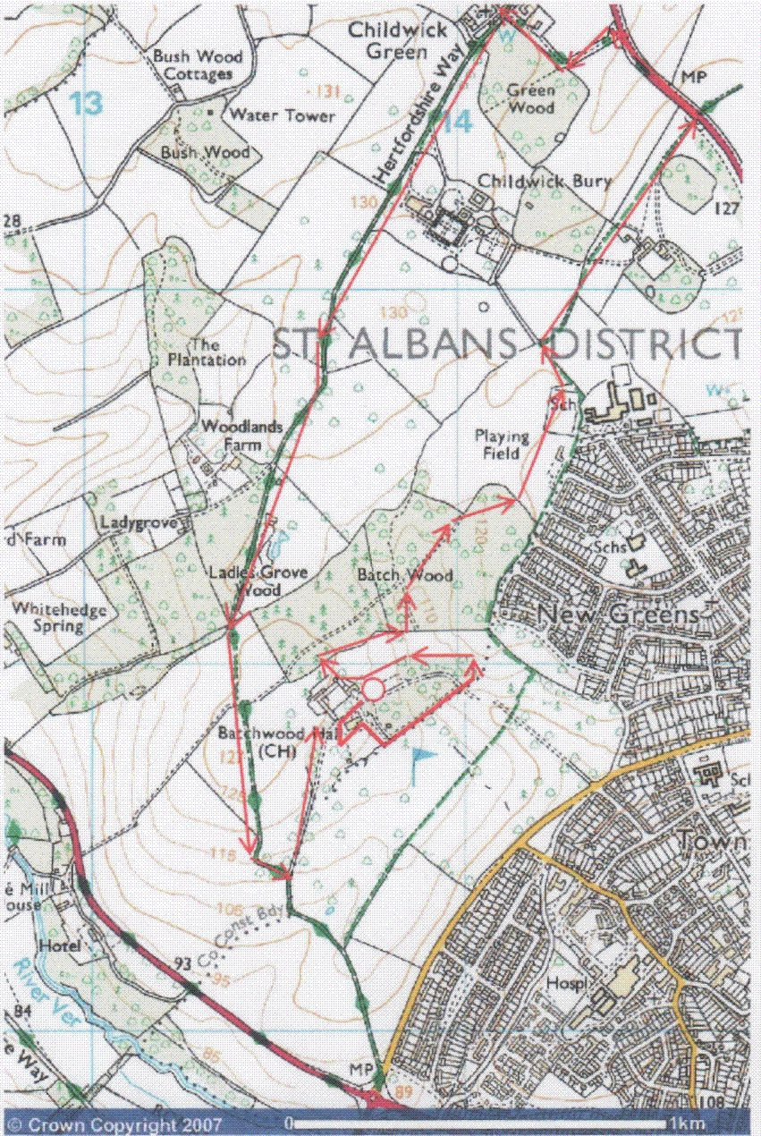

Start at Batchwood lower car park, denoted by the open red circle.

Follow the red arrows.

This mapping data licensed from Ordnance Survey® © Crown copyright 2007.
All rights reserved, licence number 100046670
SINGLE-PAGE DESCRIPTION
Walk across the front of Batchwood Hall.
Turn left at the end of the Hall, and left across the back of the Hall.
Go right along the asphalt path at the end of the Hall.
Go left opposite the ha-ha, taking the path that has yellow-and-black striped stays coming down on to its right.
Cross over the road and continue on the path opposite.
Follow the path keeping the golf course on your right until you come to an avenue of maples on the right of the car park.
Continue up the maple avenue and to the left of the tall protective netting.
Cross the fairway at the tall conifers.
Go into the woods and turn right along the path keeping the golf course on the left.
At the bottom of the hill, follow the footpath waymark left.
At the next waymark, go right until you come to open fields.
Either go out into the open fields and go right until you meet the hedge on the far side or go right through the woods, out at the end and on towards the hedge on the far side.
Go left along the hedge to the far corner where follow the bridleway waymark under trees and to the right.
Come out through a gate into a fruit farm.
Go ahead and to the right then left in front of the trees through the fruit farm.
Go out into Harpenden Road and turn left.
At the red brick and yellow stone lodge, go left through the wrought iron gates into the drive between banks of rhododendrons.
At the crossroads, go left in front of the church and continue with the green on the right.
Continue on leaving Manor Lodge on your right and then the Manor House on your left.
At the arched gate and the sign for Childwickbury Goat Farm, keep straight on along the tunnelled path.
Cross the field and keep to the right of the line of trees ahead.
The path curves left and comes out on to the drive within Batchwood.
Go left up the avenue until you see the Hall on the right.
Take the golfers’ path towards the Hall.
Pass the side of the Hall out on to the road.
Go right in front of the Hall back to the car park.
FULL DESCRIPTION with photographs

Having parked in the first car park we come to as we come up the drive into Batchwood, we walk on up the hill and come to an imposing deep-brown brick building on the left hand side.
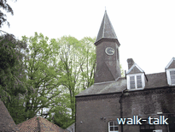
Clock turret
TL 137088
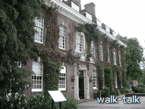

Batchwood Hall
TL137088

This is Batchwood Hall, home of Lord Grimthorpe

We can read about the clock in the turret and about Lord Grimthorpe and the Batchwood estate on the boards in front of the house.

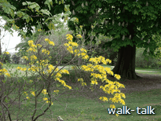
We continue in front of the Hall and go left at the far end of Batchwood Hall. There are rhododendrons on the drive and, if we are early enough, a golden azalea is on our right as we turn with the nightclub barbeque area on our left.

Azaleas on the right as we turn left at the end of Batchwood Hall
TL137088

The putting green is ahead and we go left under a holly oak in front of the Hall.
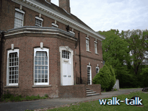
There are rose beds and the putting green on our right. If we go up on to the steps of the Hall we can see the excellent view of the Abbey that Lord Grimthorpe had.

Steps of the Hall
TL137088

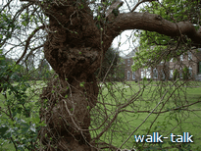
At the end of our path we go right, by two tall spreading oaks.

The next tree on our right is a mulberry, grossly burred.

Mulberry tree
TL137088

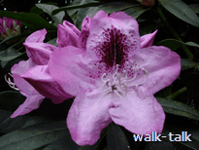
On our left is a bank of mauve rhododendrons.

Rhododendron flower in the bank on our left
TL137088

.

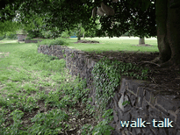
As we draw level with a ha-ha on our right, we go left, still on asphalt, although the asphalt soon peters out.

The ha-ha
TL137088

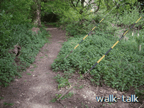
We go slightly right on to a path with two yellow-and-black-clad stays coming down to the right of it.

Yellow-and-black-clad stays
TL138088

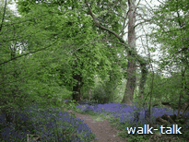
We ignore the entrance to the composting area on the left and follow the path ahead

Batchwood home woods
TL138089

We cross an open space of cut grass with a golf driving range to the right.
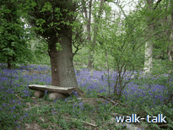

To the left is a glade with a log bench.

Log bench
TL138089

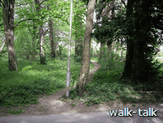
We cross the drive leading up to the Hall and Golf and Tennis Centre and carry on along the path opposite, which curves up hill and to the left.

The path across the drive
TL140089

The golf course is close on our right. We are going behind a green and the golfers might well be striking from beneath our horizon so be wary.
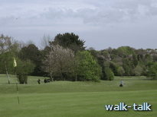
The golf course on our right
TL140090

Immediately after the golfing green, there are baskets round the tree stumps (stools) to protect the new shoots from deer and rabbits.

There is a path alongside the baskets but we ignore that and carry on.

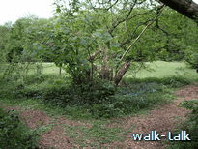
Soon the path divides and we want to go left.

Where the path divides,
we go left
TL140090

It is tempting to go straight on across the golf course but it is dodgy. There is no right of way and there is a dogleg in this fairway, which makes it unsafe.

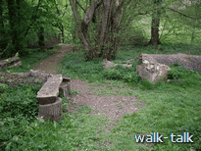
There are logs to our left and right, and the golf course is on our right.

Logs to the left and right of our path
TL140090

We go down hill and can see on the right the huge hollow in the fairway where Lord Grimthorpe dug clay for bricks.

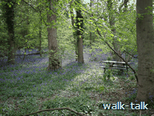
At the bottom of the hill, note the picnic bench in the woods. Apart from seeing that we are at the bottom of the hill, this will be a marker we can use when we are on the far side of the golf course, confirming that it is time there to take a turning.
Picnic bench
TL139090
We go up hill.

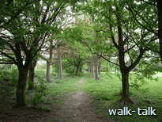
We come up with the corner of the car park on our left, the golf course still on our right and, ahead of us, an avenue of maples, which we go on under.

Avenue of maples
TL 139090
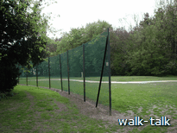

At the end of the avenue, we bear right, staying close to the trees and keeping clear of the golf course until we can be on the left of the high netting that will protect us from the golf balls.

We go left of the protective netting
TL 138090
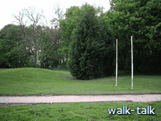
We join a golfers’ path and we go right, crossing the golf course, by the line of tall conifers.

Line of conifers
TL 137090

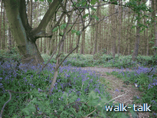
We go on into the woods ahead. If we look left we can see the light at the end of the woodland. The field beyond is the one we shall cross as we return from Childwickbury.

We go into the woods and turn right
TL 137091

We go right, along the clear wide path, the golf course now on our right, conifer woods on our left.
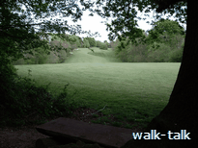
The golf course is on our right
TL 138091

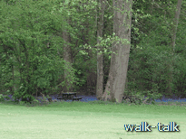

We ignore paths to the left until we get to the bottom of the hill opposite where we saw – and can still see – the picnic bench in the woods on the other side of the golf course.

Picnic bench on the far side of the golf course
Seen from TL139091

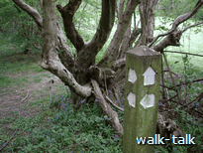
On our side, there is a waymark post with white arrows, one of which points left and that is the one we follow.

We follow the white arrow pointing left
TL 139091

The scene as we turn left
TL 139091

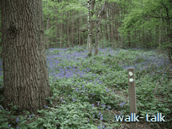
We hold our direction until we come to another waymark post. One arrow points diagonally up and to the left but we want to follow the direction of the arrow pointing right.
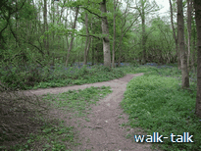
We follow the arrow pointing right
TL 139093

We pass a pair of rusting wheels on an axel. They are on our right. Ignore the path in that direction.

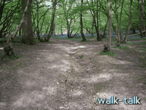
Our path has a deep gully in the middle of it, worn by water streaming down it after rain.

Deep gully in our path
TL 139093

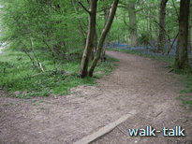
We come to a spaghetti junction of paths. We can see open space with football posts ahead and, if we feel we would like to be in the open we can go out into the field and make our way, zigzagging round the football pitches, to the far diagonal corner of the field, ahead and to the right. On the other hand, we can take advantage of the shade of the woodland and continue just within it, keeping the field within sight on the left.

Continuing just within the wood,
with the field on the left
TL 140099

As we continue, the woodland bulges out into the field a bit so that the edge gets a bit further from the path but we keep left rather than right until we are out into the field further on.
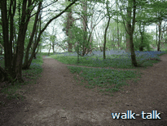
We keep left rather than right
TL 141099

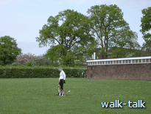
The houses along Toulmin Drive are on our right and the football changing rooms are ahead of us. They are in a single-storey building of dark brown brick with a shallow row of white-framed windows under the roofline.

We make for the hedge beyond the changing rooms, leaving them on our right.
The changing rooms
and the hedge beyond
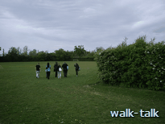
TL 142096

We zigzag to avoid the pitches. When we reach the hedge we follow if left (so that it is on our right). Townsend School is on our right over the hedge.

We follow the hedge left
TL 142097

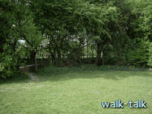
In the corner of the field we see a blue bridleway waymark on a post. We follow the direction of its arrow to the right.
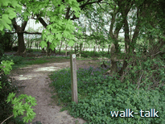
The corner of the field and its blue bridleway waymark
TL 142098

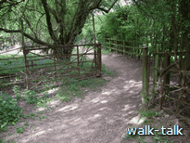
The path wiggles at a gate that looks as if it is permanently open.

A wiggle in the path at a gate
TL 143099

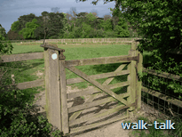
We come out at a gate with a distinctive heavy metal square closer.

Gate with a heavy closer
TL 143100

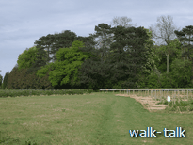

The bridleway waymark arrow points diagonally right and the path goes straight ahead for a bit and then bears right between fruit planting.

Path through the fruit farm
TL 143101

The pick-your-own shed is soon on our right and then the farm house and outhouses. The sign says Hawkswick Lodge Farm.
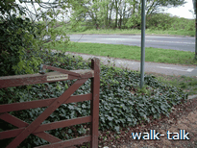

We come out on to Harpenden Road and go left along a pedestrian and cycle path.

Gate on to Harpenden Road
TL 147105

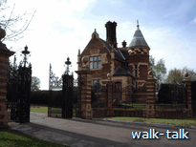
Soon on the left we come to the amazing late Victoriana red brick and yellow stone lodge and gateposts at the entrance to Childwick.

Lodge and gate to Childwick
TL 145107

We go through the splendid wrought iron gates
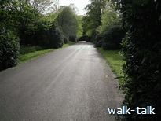
and between the astounding banks of rhododendrons that flower in late May and June.

The drive to Childwick
TL 147102

The drive turns right and then we come to an intersection.

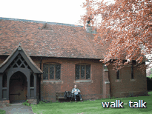
We turn left, leaving the church on our right.

St Mary’s church
TL 141108

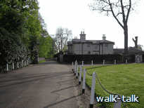
We continue on the road leaving the church and the green on our right.

Ahead is the Manor lodge.

The green with the Manor Lodge beyond
TL 140106

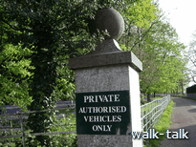

We go to the left of the lodge, undeterred by the sign that says that this is a private road for vehicles. It is a public bridleway.

One of the posts to the left of Manor Lodge
TL 140106
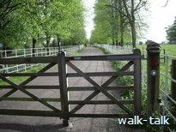

We come to a security gate across the road and there is a small gate at the side with a waymark and “Push” on it. That is what we do: push, and go through it.

A security gate
TL 140106

We come up to the manor house on our left. The gates have gold-painted feather-like leaf decorations as well as the usual tight curly bits.

The gate to Childwickbury Manor
TL 139104

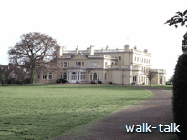

Childwickbury Manor House
TL140103

We continue along the asphalt road we are on.

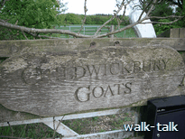
When we come to a carved wooden sign to mark the entrance to the Childwickbury Goat Farm on our left

Entrance to the Childwickbury Goat Farm
TL 135095
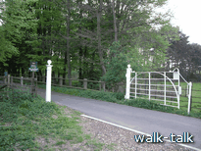

and an arched metal gate, usually open, a bit to our right,

Arched metal gate, usually open
TL 135095
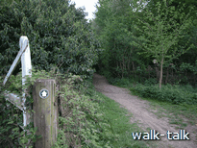

we want to go absolutely straight ahead down a path tunnelled by over-reaching trees.

Our path, tunnelled by overhanging trees
TL 135095

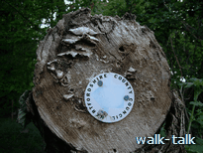

Our bridleway waymark is in an unusual position: on the curved end of a tree trunk.

Unusual position for our bridleway waymark
TL 135095

We walk with the farm beside us on the left. Ladiesgrove Wood is ahead and to our right, Batchwood ahead and to our left.

Our path comes out at a field and we carry straight on through it. The path is always clear even when crops are planted. This route is well trodden and well cycled.
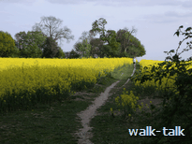
As the trees on our right slope away from us – Ladies Grove Wood giving place to Whitehedge Spring – we come out into a field.

We hold our direction and cross the field.

Our path straight ahead
TL 134091

As we come level with the tree line ahead, we see the waymark permitting us to walk left, which would be a short cut back to the Golf and Tennis Centre if we kept close to the trees until we are level with the Centre buildings and cut through between the green and tee at the conifers where we crossed before.
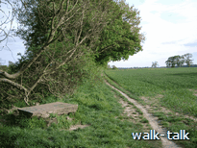
However, for maximum rhododendron viewing and a good long view, we go straight on in the direction we have been walking, keeping to the right of the line of trees.

Our path to the right of the line of trees
TL 134089

The golf course is on our left.

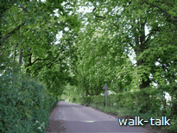
The pathway curves markedly to the left and then we come out on to the road through Batchwood and go left along it under the magnificent avenue of horse chestnuts.

The avenue through Batchwood
TL 136085

If you cannot bear to be on asphalt, go through the hawthorn hedge on the right, but stay between the hedge and the line of trees to be as clear as possible of golf balls being driven up the fairway on the right.

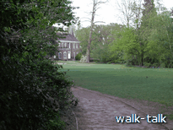

When we see Batchwood Hall we take the golfers’ path that curves right towards the Hall.

The golfers’ path that curves right towards the Hall
TL 136087

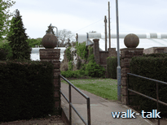
As we come level with the corner of the Hall, we can see the road that takes us right, back across the rear of the Hall to our car park, but perhaps with a pause for refreshment at the Leisure Centre.

The path to refreshments
TL137089

