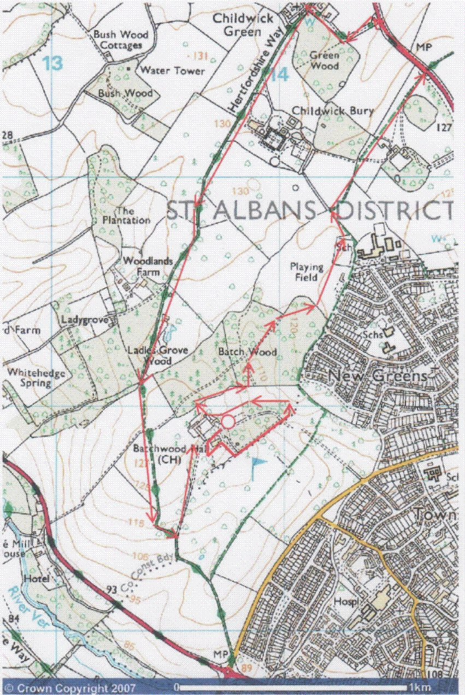

This mapping data licensed from Ordnance Survey® © Crown copyright 2007.
All rights reserved, licence number 100046670.

Start at Batchwood lower car park, denoted by the open red circle.

Follow the red arrows.

