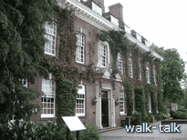
Batchwood Hall was the home of Lord Grimthorpe, saviour or desecrator of St Albans Abbey fabric, depending on your view. He acquired the land from the Gorhambury estate, of which more later and built the house. It is a nightclub now, refurbished after a fire a year or two after the millennium in cool blues and greys. There are separate spaces for different kinds of dancing and for sitting to talk, for eating and drinking and so on.
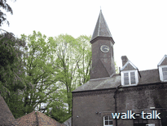
Look up at the clock turret on the near side of the Hall. Lord Grimthorpe, then E D Dennison, designed the clock that we call Big Ben (strictly the name of the bell) and ought to call the Westminster Clock. The clock in the turret was also designed by Lord Grimthorpe and is regulated by his famous Dennison escapement. The clock was repaired for the millennium.

You can read about the clock in the turret and about Lord Grimthorpe and the estate on the boards in front of the house.

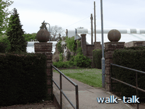
Lord Grimthorpe is reputed to have had a telescope so that he could keep an eye on the men working on the roof and on the west face of the Abbey.

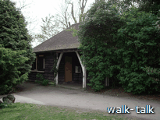
The high brick wall we see by the path on the opposite side of the road to the Hall, was part of a walled garden. The herbaceous border between it and the path is a picture at different times of the year: bulb flowers in spring, poppies and hollyhocks, climbing roses and lilies in summer. There are some impressive wrought iron gates in it above graceful rounded steps.

To the right and on the far side of the putting green is a small wooden building. It is clad in elm planks, great thick beautiful ones, perhaps the last we shall ever have.

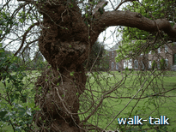

The next tree on our right is a mulberry, a white mulberry, the kind whose leaves are the food of silk worms. If it is mulberry time, be respectful of the fruit: it stains irrevocably. The trunk is grossly burred.

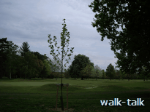
Beyond the mulberry, and in line with it and the two oaks, is a London plain tree and to the right of that, in good view from the main windows of the Hall, is a London plain sapling that was planted to commemorate the hundred years since the death of Lord Grimthorpe.
The tree named for London and so closely associated with the capital, keeps us in mind of the Westminster clock and its escapement that he designed.
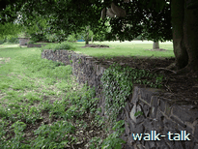
The sapling is on the edge of a ha-ha, which protected the gardens from animals without spoiling the view from the house

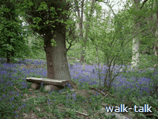
Friends of Batchwood work tirelessly to manage the precious ancient woodland, create these lovely paths for us and create places for us to rest and absorb the tranquillity and beauty. They welcome support, both practical and financial. If you would like to support them, the person to contact is Miles Soppett, Friends of Batchwood, c/o Batchwood Golf and Tennis Centre, Batchwood Drive, AL3 5XA.
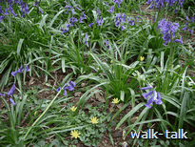
In late April there are bright yellow celandines and white wood anemones in amongst the bluebells.

On the rise to the right above the drive up to Batchwood, are baskets round tree stumps (stools). The baskets are excellently made, in the tradition used after coppicing for millennia to protect the new shoots from deer and rabbits.

In Batch wood on the far side of the golf course, note how little grows beneath conifers. There are scrubby brambles and that is about all. Note that there is the occasional standard oak left amongst the pines. I suppose the foresters felt that they would eventually be of value even if not in the time they hoped to get their return from the pines.

There are interesting wood banks in Batchwood towards the New Greens playing fields. There is known to have been at least one mediaeval dwelling in this part of the wood. In this part of the Wood, the hornbeams each have multiple trunks, showing that they were coppiced - but a long time ago because they are huge trees now. You can sometimes hear a woodpecker knocking near here.

Batchwood was part of the Childwickbury estate in Saxon times. It has its name from the Bachesworth family who owned it at the close of the thirteenth century.

Saturday and Sunday league footballers use the changing rooms and playing fields on Toulmin Drive.

The fruit farm on Harpenden Road has pick-your-own in late summer. Strawberries on high, irrigated channels are on our right and raspberries and then currents on our left. The bank of trees ahead and then to the right of the footpath is most attractive. There is a towering horse chestnut with an even taller solitary ash tree to its right. Close to the horse chestnut are pines and on its left is and oak, its foliage cascading down. Away to the right, behind the strawberries there is a copper beech and away over our right shoulders we see slate roofs and more copper-coloured trees.

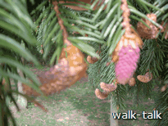
As we get close we see that the conifer cones have fascinating shapes and colours: the one lot buff coloured and as perkily curved as a cashew nut, the others the shape of a tiny spinning top, a mass of pale crimson spores that disperse in a cloud as they are disturbed.

Beneath one of the rows of fruit plants on the left is a sign “Ben Connan”. Is that the name of a particular berry?
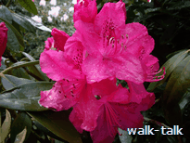
The rhododendron flowers on either side of Childwickbury drive seem to be of every colour and marking and size, each one a piece of perfection, blousy and open and voluptuous.

I adore rhododendrons. I think they are a sensuous beautiful flower but in the wild in Britain, because their dense permanent foliage shuts out all the light, they threaten the more delicate native flora and fauna.

In some countries rhododendrons grow into huge trees with leaves a yard long (from the tip of your fingers to the tip of your turned-away nose).

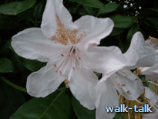
The dwarf hybrids are called yaks, not because they come from the heights of the Himalayas where they and yaks thrive on the rare atmosphere, but because they are bred from the dwarf species R. yakushimanum. The word has a lovely sound and it would be interesting to know its origin, but I like, too, other more obviously descriptive names: pink pearl, bashful (a dwarf variety?), morning magic, gold dust.

We could try matching the names to the flowers in Childwickbury drive – or make up names for them. I think I have spotted gold dust and I shall name one of the other freckles and another lady’s boudoir.

Childwickbury drive is also a picture of flowers at daffodil time and at bluebell time – and at any time is a picture of dark green foliage backed by beautiful British trees. Also, the views between the rhododendrons are picturesque: on the right, grey-green leafed trees, maroon-leafed trees, jaunty chimneys, paddocks and horseboxes and old rooftops; on the left dun, tawny and black-and-white cows that stare curiously at us from a wide meadow with woodland beyond.
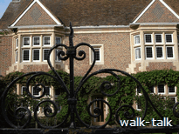
In early summer, there is usually a charity open garden day in Childwick Green. It is a treat.

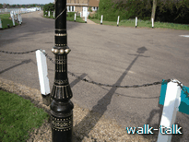
Note the black and gold, no less, detail on the lamppost at the corner and the super copper beech tree at the top of the drive and now in front of the church.

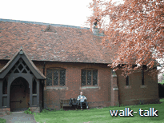
The church is St Mary’s and was designed by George Gilbert Scott and built in 1867 by the Toulmin family who owned the Childwickbury estate. We passed by Toulmin Drive as we came out of Batch Wood on to the football fields, you might remember.

When the Toulmins found that their tenants were loath to walk all the way to St Michaels on a Sunday, he called their bluff and took away their excuse by building a church on the Green.
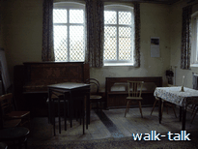

They built also an adjoining schoolroom and Henry Joseph Toulmin and his wife Emma (or Emily) taught their tenants, many of them elderly, to read and write.

The darker line down the middle of the floor is a heating duct in decorative metal. It is in the church, too.

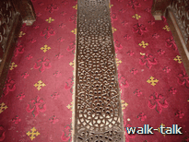
I owe much of this information, and the information below about the church and Childwick to the leaflet to be found in the church.

The leaflet welcomes EVERYONE, underlined and in caps, to the evening services held every Sunday at 6pm. There is holy communion at the evening service on the first Sunday of the month. I think you should risk a visit: the interior of the church is a treat:
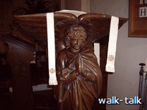
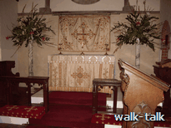
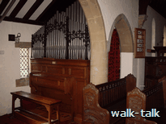

Inside St Mary’s

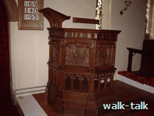
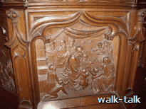
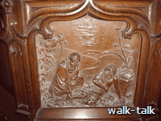

The Faith Hope and Charity windows in the Chancel are in memory of Henry and Emma Toulmin, as are some gates at St Michael’s church and a window in the Abbey.

It was Henry Joseph’s father, Henry Hayman Toulmin, who bought the Childwickbury estate in either 1851 or 1854 (each date is quoted). He was a shipowner.

Henry Joseph and Emma lived at Childwickbury with his parents when they were first married. Then they moved to the Pre which they rented from the Earl of Verulam, the Pre being the dower house of the Gorhambury estate. After Henry Joseph’s father died they moved back into Childwickbury for a while but then, in 1881, sold the big estate and returned to the Pre. We shall pass above the Pre towards the end of our walk.

It was to Sir John Blundell Maple that HJ Toulmin sold the Childwickbury estate in 1881. Sir John’s father John Maple had owned a small furniture shop in Tottenham Court Road. The rest is history: the son was an imaginative business man and the firm became global players, importers of timber and manufacturers and exporters of furniture. Maples “furnished palaces all over the world, including Tsar Nicholas's Winter Palace, the Hofburg Imperial Palace in Vienna, all the great hotels, and town and country homes. Prestigious British embassies were all furnished by Maples, even if it meant carrying the grand piano up the Khyber Pass on packhorses.”

Sir John enlarged the church and the schoolroom, which was used as a school until 1925, and then again for evacuees during the second world war.
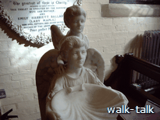
Two Sir John’s daughters died of scarlet fever. They were very young and it must have been heart rending to lose them, in successive years. In their memory, Sir John commissioned and donated the exquisite marble font in the church. The faces of the angels that support the shell font are not stylised or pretty and I think the angels must be likenesses of the girls.

It is a lovely memorial – and a very special font. Not only the font and a plaque on the wall behind the font commemorate the girls: Sir John had recognised the need for an infectious diseases hospital and had one built in St Albans. He called it The Sisters Hospital.

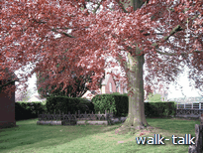
The Maple vault is in the churchyard behind hedges and a wrought iron fence and, according to the church leaflet, “contains the coffins of Sir John and Lady Maple and their three daughters”. I have found reference “His only surviving daughter married Baron von Eckhardstein, of the German Embassy, in 1896.” I do not know whether this is the third daughter buried in the vault or whether there was a fourth daughter.

Sir John left the estate to his widow and she “allowed the people of St Michael’s and St Mary’s to make the Church their own for a nominal sum”. I love the wording. The leaflet says that this was “to ensure that it would always belong to them”.

It was Sir John Maple who had founded the stud on the estate but it is Jack Joel, who bought the estate at auction in either 1906 or 1907 (according to the leaflet) who is more famous for his horse breeding. Jack and his brother Solomon Barnato Joel “had made their fortune helping their uncle, Barney Barnato, in South Africa. Barnato had helped found the DeBeers Consolidated Mines in partnership with Cecil Rhodes. Later, Barnato made an additional fortune in gold mining. The brothers invested in their uncle's financial empire, and enjoyed a considerable inheritance when their uncle died by suicide in 1897. Solly and Jack Joel returned to England, where the former founded Maiden Erlegh Stud, and the latter Childwick Bury.”

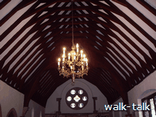
The church leaflet tells us that Jack’s son H J Joel, known as Jim Joel, inherited the estate from his father in 1940 and “made many generous gifts to the church including the chandeliers and the marble pillars in the chancel”.

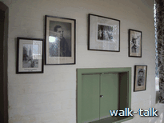
There is a small collection of photographs on the wall of the schoolroom. One of them is a gathering in 1967 and is labelled “Centenary Celebrations”, confirming that the church was built (by the Toulmins) in 1867.

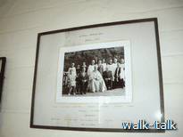
The photograph shows the bishop in the centre with the mayor and then the mayor’s wife on one side of him and Jim Joel seated on the other side of him. Standing immediately behind and between the bishop and Mr Joel is the church warden, Edwin May, who was a chorister and also butler to Mr Joel. Behind and around the church warden are other members of the choir, which is no longer in existence.

The Maundy Money which is in the wall at the back of the choir stalls was given to Edwin May by the Queen when she distributed the Royal Maundy in St Albans Abbey in 1957. Edwin May bequeathed the Maundy Money to the Church.

The Women’s Institute uses the schoolroom regularly and so do a stamp collecting group and the women’s graduate. The room and tea and coffee making facilities are available for hire at a nominal rate.

In 1978 the estate was divided and sold. The Marquesa de Moratella bought the stud farm and Stanley Kubrick, the film director, bought the manor house. Films directed by Kubrick include Spartacus (1960), Lolita (1962), Dr Stangelove (1964), A Space Odyssey 2001 (1968) Clockwork Orange (1971). Eyes Wide Shut with Tom Cruise and Nicole Kidman was his last film. Kubrick died of a heart attack only days after screening a final cut. He was 70. It is said that he is buried in Childwickbury next to) his favourite tree.

Kubrick’s widow Christiane Kubrick lives at the Manor. She hosts the prestigious Childwickbury Arts Festival each summer. There are exciting music concerts, we can make and glaze pots in one of the manor outhouses, all kinds of works of art are on display, we are invited to display our art and participate in other ways, and the stables are open for refreshments. This year, 2007, the Fair is on the 6th, 7th and 8th July. To find out more go to http://www.childwickbury-arts-fair.com/.

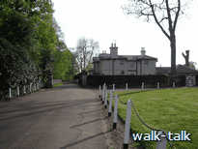
The substantial attractive houses on the edge of the green were built about the turn of the last century - towards the end of the time of the Maples’ ownership. It is known that workers cottages were pulled down about or before this time. It is thought that they would have been where the green is now.

Ahead is the Manor lodge. In his time, this was the home of Edwin May.

Childwickbury was given to the abbot and monks of St. Albans Abbey by Ailwin Niger and Ailfleda his wife at the instigation of King Ethelred II, in the later part of the tenth century. That is the 900s: pre conquest.

The land was taken back by William Rufus then given back to the Abbey then seized in 1290 by the king's ‘escheator’ and that seems to have set a pattern of Mugabe-worthy ‘appropriations’ and ‘assignments’ and ‘seizings’ of the manor by kings and abbots, the income from it being variously allocated to the ‘maintenance of the prior and convent’, the ‘anniversary of an [particular] abbot’s soul’, then to ‘the provision of bread for the monastery’, then back to the prior and convent, then for the ‘improvement of the bread and ale of the monastery, later to ‘provide one loaf and two herrings each for 300 poor persons at the feast of All Souls, for the souls of Pope Boniface VIII and Abbot Roger de Norton’. On that last occasion the abbot ‘reserved to himself homage, wards, marriages, reliefs, &c., belonging to the manor, and view of frankpledge there’ whatever frankpledge was.

The church leaflet has an intriguing statement on the relationship between the manor and the Abbey: ‘The monks then learned a vocation and supplied the Abbey with milk – hence the name Child wick or young people’s dairy farm.’ Were the monks particularly young? Does wick mean dairy farm? Chambers adds “farm” to the more widely given “village or settlement” under wick - but not “dairy” or “dairy farm”.

After the dissolution of the monasteries by Henry VIII, the estate passed into private hands and was bought in 1666 by Joshua Lomax, a man from Bolton, Lancs. I wonder what brought him south. The Lomax family built the house that we see and lived in it for 200 years, selling it in to Henry Toulmin.
Through the hedge between us and the Goats Farm, we get glimpses of small wooden shelters. The farm sells its superb soft goats cheese on the St Albans market, along with an exceptional range of interesting cheeses. The farm keeps bees as well as goats.

Small birds dip across the tunnelled path.

Up the hill on the other side of the valley, the Ver Valley, on our right must have come Boudicca’s followers fresh from the sacking of Verulamium. Or so we assume for “signs of burning have been found dating from the time at the well-to-do farmstead at Gorhambury” (Rosalind Niblett, 1995, Roman Hertfordshire”. Ms Niblett goes on to say that “recovery after the revolt seems to have been rather slow…the farmstead at Gorhambury.., which had been a thriving concern in the 50s, was reduced by the late 60s to a number of simple round huts.” (ibid)

Although Ms Niblett refers to the area as Gorhambury, that name is of Norman extraction and comes from the family that occupied the manor from the 1150s. Before that, and for much of the time even after the de Gorhams occupied it, the manor was known as Westwick. We know that the Manor of Westwick was bequeathed by Æthelgifu to Queen Ælfgifu about 942–6, and was granted by King Ethelred in 996 to the monastery of St. Albans.

The de Gorham bit comes in when “Abbot Geoffrey de Gorham built a hall at Westwick for the use of one of his friends and kinsmen, a benefactor of the church.” That was 1150. The kinsman was one Humbold who took the name de Gorham when he married Geoffrey’s sister. “Keeping it in the family” was the title of a talk by Ann Dean, eminent local historian, to the Architectural and Archaeological Society on 8 May 2007. She demonstrated how true that was of the Gorhambury estate right through the ages.

The Peasants revolt in 1381 was triggered by the introduction of a poll tax and called for an end to serfdom and unjust labour laws, but the background of patronage and expropriation and exploitation was all part of the awful situation of the time. What few gains that were made by the rebels were short lived. “The men of Westwick, like so many others of the tenants of the abbey, obtained a charter of liberties from the abbot at the time of the rebellion of Wat Tyler, (fn. 69) a charter which, like all the rest, was withdrawn at the suppression of the rebellion.” (See 'Parishes: St Michael's', A History of the County of Hertford: volume 2 (1908), pp. 392-405. URL: http://www.british-history.ac.uk/report.asp?compid=43300. Date accessed: 09 May 2007.)

At the dissolution of the monasteries in 1539, the property reverted to the Crown and was bought by Ralph Rowlatt the following year. The estate stayed in the Rowlatt and Maynard (kinsmen to the Rowlatts, of course) families until it was sold in 1560-1 to Nicolas Bacon, lord keeper of the great seal.

Nicholas Bacon pulled down the Hall built by Geoffrey de Gorham and built a substantial house, the ruins of which are behind the elegant porticoed house that we can just see over our right shoulder. It was built in 1784.

Gorhambury House is the home of the Earl of Verulam and his family. It has been in his family since the late 16th Century.

The living of St Michael’s, and so too of St Mary’s Childwick Green, is in the gift of the Gorhambury estate, and the Earl of Verulam takes his responsibilities seriously and played an active part in the selection of the new vicar, appointed this year (2007). It brings to mind the dramas in Jane Austen’s novels when the granting of a living could be crucial to the happiness of a young woman who had hopes of the attentions of a man in orders.

After the field by Ladies Grove Wood and Whitehedge Spring, we come to a very high point. The tree standing somewhat on its own on the golf course has been struck by lightning more than once.
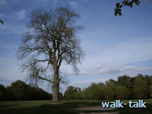
I think by the upwards lilt of its branches that it is an ash. It has no foliage, either because it has been struck once too often or because this year we are in for a splash rather than a soak, the oak being well out before the ash.

Across to our right we see the poplars along the line of the Ver in the Gorhambury estate. They were planted at a time when their wood would have been valuable for making matches. Bryant and May were called in to advise on the planting. Unfortunately for the investors the bottom had fallen out of the match business by the time the trees came to maturity. Fortunate for all who pass this way – and along Redbourn Road – because I think the trees soften the landscape and add to its interest.

Note the high bank up to the golf course as the pathway curves markedly to the left.
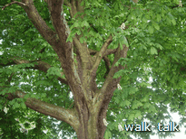
It looks as if it has been terraced. However, the bank on the right is also high and we are led to wonder if this used to be a drovers’ way.

Take time to look up into the foliage of the pair of beautiful horse chestnut trees at the corner of Batchwood Hall.

Refreshments are to be found by reception within the Golf and Tennis centre. Take the path between the ball-topped brick posts.

