This is a 4-mile walk from Pursley Farm, Shenley, through fields and meadows and alongside woodland to Ridge, and back by Ravenscroft Farm through wilderness and more fields back to Shenley.

Ridge has a fascinating church with a 15th century lively fresco of St Christopher carrying the Christ child and furniture by the Mouse Man of Kilburn Yorkshire. The church is open on Sundays July to September 2.30pm to 4.30pm and serves tea and homemade cake during those times.

The houses in the village have varied architecture and pretty gardens.
Views are long and wide.

Start and finish: The White Horse, Shenley, 37 London Road, Shenley, WD7 9ER. NGR: TL 191002. Phone: 01923 856315.

Refreshments: The White Horse has a full menu and good range of beers, as does The Old Guinea, Ridge, EN6 3LH. NGR: TL 215004. Phone, 01707 642126.

Tea and homemade cake is served in St Margaret’s church, Ridge, on Sundays 2.30pm to 4.30pm July to the end of September.

One way to get there from St Albans:
- Leave town on London Road, go exactly a mile and turn right at traffic lights into Mile End Road.
- Go under the railway bridge and immediately left into Harperbury Lane. It is now pretty well straight to The White Horse.
- Following signs to Shenley, you are on the B5378 which becomes Shenley Lane at it skirts London Colney, then Shenleybury after it crosses the M25, Black Lion Hill as it climbs the hill to Shenley, and London Road as it goes through Shenley.
- The White Horse in on the right, opposite the post office at the far end of Shenley.
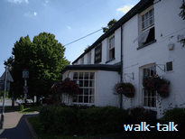
We turn right out of The White Horse, TL 191002, and cross the road signed to Borehamwood.
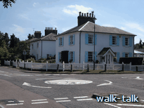
We continue along the pavement in front of a
variety of houses.

We see on the other side of the road, the manky willow tree alongside the path along which we shall return.
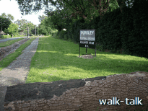
On our side, we pass the Pursley Farm football field.
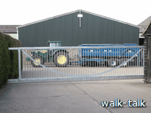
On the opposite side of the road, we pass the first entrance to a farm and then, about 25 yards further on, there is another entrance to the farm alongside a big black weather-boarded barn with a wonderfully steep roof. On the roadside is a board saying “The Hunters Herd, Pursley Farm” and also a footpath sign “Public Footpath 18, Mimms Lane”. We cross the road - taking care because cars travel fast along here - and enter the farm through a sliding gate with a slot on the left for pedestrians. TL 194000.
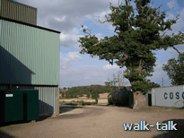
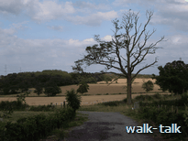
We angle a little towards the house on the right then bear left towards a barn with sage-green corrugated cladding.
There is a hedge round the house on the right then a wonderful oak and some tanks.
We curve right towards a half-dying ash.
There is a new hedge on our left.

Then the farm track curves left and
we straighten out and walk along here, with an older hedge on our left, for a good long way.
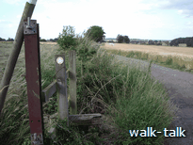
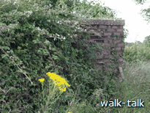
We pass a Second World War pill box on the left.
We curve right and then left round young oaks.
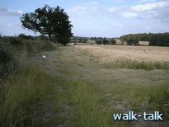
The track straightens out and we go under a three-strand line of electricity wires.
Now we have crops on the right and a line of oaks in the hedge on our left.

When we come to the edge of the field, TL 201005, we carry straight on into the barley on the path that cuts clearly through the planting.
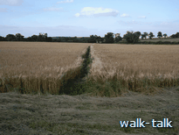

At the far end of the field, there is an oak tree
with a great cleft in it. Next to the tree is a County waymark post with its yellow footpath arrow.
On the oak itself are one and a half Shenley-walk waymarks. One is numbered 4 but who knows what the other one is.
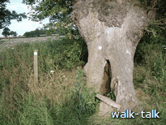
This oak is the pivot point of the great W we are walking on our way to Ridge and the M we shall walk on the way back.
It is worth looking round to see where we are. TL 202006.

If we look ahead and to our left along the valley, we see the way we shall come from Ravenscroft Farm and this oak is what we shall want to aim for.
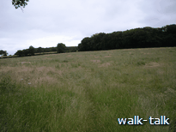
If we turn round, we see that there are three footpaths radiating out behind us. The one on the left (south) is the one we have just traversed. The centre one is the one that we shall want on our return.
We turn back again and veer right (110º) cutting diagonally upwards across the meadow ahead aiming for the left hand end of the solid bank of trees ahead, Bigpursley Wood and, beyond that, the right hand end of Litlleridge Wood.

The path is not well defined but the going is easy.
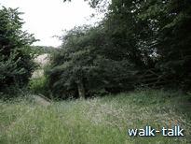
As we reach the corner by Bigpursley Wood, TL 205005, we cross a deep ditch by means of a wooden-board bridgelet. The edges are raised but boards like these can be very slippery in the wet.
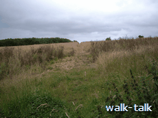
As we come out into the next field, we want to continue in the same direction through the rape-seed direction.

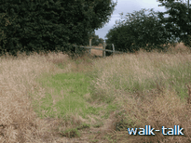
We are aiming for the right-hand end of Littleridge Wood ahead of us.

As we reach Littleridge Wood, we go over a stile and then cross another ditch by means of sleepers.
TL 207004.

We turn left and walk along a wide track with bark chippings underfoot. Littleridge Wood is on our left.
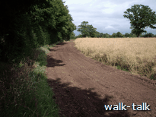
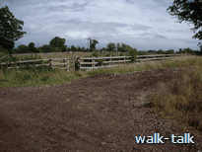

As we reach the end of the Wood, the bark-chipping track curves right and we go almost straight on through the wooden kissing gate with a rope fastener. TL 208004.
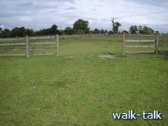
We enter another paddock and go through a gap in the fence
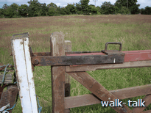
and then through a gate with a strong iron keeper, into another paddock.
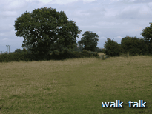

We aim for a spreading oak, a good bit left of an animal shelter.
As we approach the spreading oak, we see a footpath waymark on the edge of the hedge.
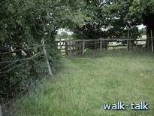
We go a bit further into the corner of the paddock, TL 210004,
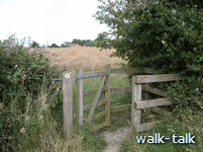

through a kissing gate and into a meadow.
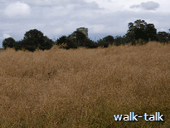
The path is clear to the next kissing gate, TL 211004.

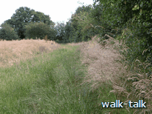
We ought to be able to go straight ahead now but here but, unless the crop has been harvested, there is no way through. We are aiming for a gap in the trees to the left of a tall oak to the left of the church tower. If we look carefully, the top of the church tower can be discerned behind the trees in my photograph. It is clearer in reality
What we have to do is skirt the field, turning right as we come through the kissing gate, then left and left again round the field.

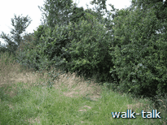
After we have turned left at the second corner of the field, we need to keep a good eye open for the gap in the hedge with a bit of a stile, TL 214005.
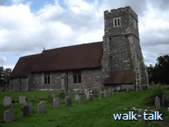
We go through the gap into the churchyard and turn right towards St Margaret’s church.
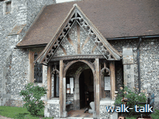
If it is a Sunday in July, August or September between 2.30 and 4.30pm, we shall find the church open and it is well worth going in to see the mediaeval fresco depicting St Christopher and the furniture made by Robert Thompson, known as the Mouse Man of Kilburn, Yorkshire.
We enter the church through the porch on the far (south) side.
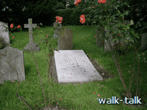
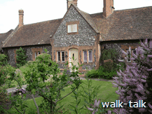
Leaving the church, we go straight down the path from the porch and, just before we reach the gate, we look over to the left and see a white headstone, close to the ground, almost horizontal but slightly sloping up at the far end. This marks the grave of Field Marshall 1st Earl Alexander of Tunis.
We go out on to the village green and straight over the road ahead to look over the gate at the long view south then turn right and go through Ridge village. Orchard Mead is said to have been designed by Sir George Gilbert Scott and the gardens by Gertrude Jeckyll.
Opposite Rose Cottage, before the de-restriction sign, we cross the road and go through the kissing gate, TL 213003, by the sign “Footpath 22” and into a paddock.
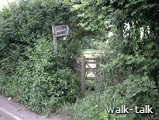
We make for the kissing gate to the right of the wide metal gate straight ahead
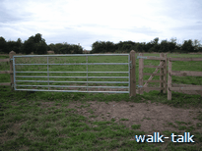
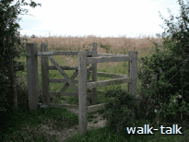
and then straight on and again through another kissing gate, and out into the field that we skirted earlier. We turn left and then, at the end of the field right.
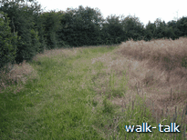
We pass the kissing gate that we came in through. and continue on down the hill.
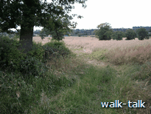
We go under our familiar three-strand overhead wires, and then another lot of the same.

At the end of the hedge, TL 210007, we curve left and then right, straightening up to continue (315º), a bit left of our previous direction, going to the left of the oak ahead.

Far ahead of us and a bit to the left is a Dutch barn, one with a barrelled roof. To the left of that is a cream and brown house and to the left of that a cream house.
That is Ravenscroft Farm and surrounding places and we want to be to the right (east) of them.

We continue in the same direction as we pass a hedge going away from us to the right.
As we cross this field we need to be wary of unexpected holes in the ground that can turn an ankle.

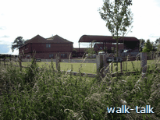
Now we come to the corner, TL 207009, of the four-barred fence around the house,
We keep on in the direction we have been walking, keeping the fence on our left.

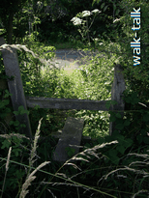
We pass under a two-wired post.

It looks as if there is no way through at the end of this path but there is: we go through a gap and something of a stile TL 207010.

Be particularly careful crossing the wooden bridgelet over the ditch out on to the road because the boards slope and are slippery in the wet,
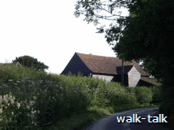
and the road, Mimms Lane, is narrow.

We go left along Mimms Lane. We can see a Ravenscroft Farm barn ahead and on the left. I suggest we keep to the left, on the outside of the curve, where there is a bit of verge to leap on to if necessary. Cars speed along Mimms Lane and it is narrow.
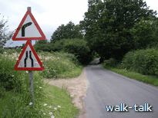
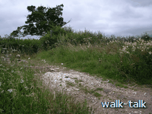
We continue on beyond Ravenscroft about as far again. The road starts to slope down quite steeply to Catharine Bourne and, immediately after road signs, the hedge curves left and we curve with it, left up a short steep slope.

The sign high in the hedge says only “Public Footpath”.
TL 204008.

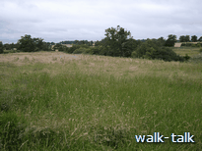
We come out into a rough scrubby meadow. There is no sign of a path across. We must make our own way across straight ahead, roughly 225º (south west)

The line of the Bourne is heavily treed and we walk parallel to it keeping it on our right.

We aim for an oak and a good gap in the hedge in the corner of the open space ahead of us.

The oak turns out to be our old friend with the one and a half Shenley-walk waymarks tacked to its breast, TL 202006.
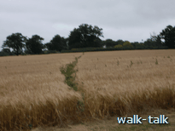
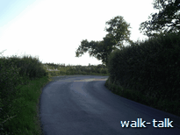
This is where there are three paths through the field ahead. We want the one in the middle that slants upwards at 280º (just north of west).
We come out on to the road again, TL 199007, still Mims Lane.
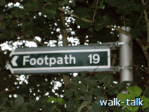
What we have done is walk two sides of a triangle to avoid having to keep to the road. We go left on to the road, then follow it as it curves immediately right then straightens out and soon we can see “The White Cottages” coming up on our right but,

BEFORE we get to the cottages themselves, about opposite their entrance, there is a gate on the left and a gap in the hedge marked Footpath 19. TL 197007.

We go through the gap and go straight ahead on to a footpath that is going to lead us straight back home to London Road, a little nearer to Shenley (and The White Horse) than our Pursley Farm entrance.
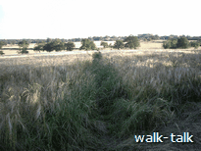
if we look up at the horizon we can just make out the sage-green barn of Pursley Farm. We want to head a bit to the right of it.
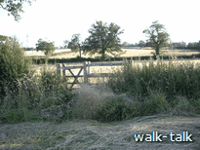
We come up to a kissing gate and go through.
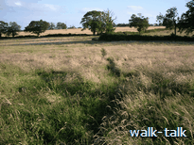
The path goes down bearing a bit to the left aiming for the end of the hedge ahead.

At the end of the hedge,
TL 196004, there is a wooden bridgelet across the ditch and another kissing gate, which we go through
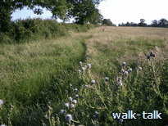

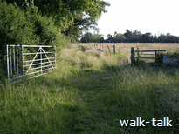
and head straight up the hill with the hedge on our left.

There is an aluminium-coloured gate that is usually set open but, if not, we go through it.
We go on, still with the hedge on our left.

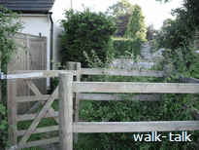
We go through another kissing gate close to a house on our left, pass the house and out into London Road, Shenley. TL 193001.

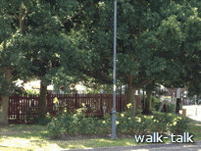

We cross London Road and turn right,
then cross Woodhall Lane, TL192002,
to The White Horse.

