To see snowdrops growing wild in woodland is a rare treat. This walk has a short route (2¼ miles) or a long route (4 miles/2 hours). Wear wellies or proper walking boots to cope with mud.

We start at The Cross Keys pub, which is between Wheathampstead and Kimpton. To get there from St Albans, we go out of town on Sandridge Road, which becomes St Albans Road, Sandridge, beyond the traffic lights at the King William IV. We go through Sandridge and Wheathampstead and straight across the roundabout at the far end of Wheathampstead. We are on the B651. It is confusing that soon after Lower Gustardwood the B651 takes a 90 degree turn to the right. This is the road we want to take. It is Ballslough Hill and, as we turn into it, The Cross Keys is on the left.

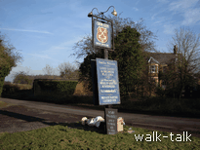

Cross Keys pub sign
GR 175 165

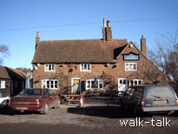

Cross Keys pub
GR 175 165

The Cross Keys does good bar food and is willing for a group of up to 5 cars to be left in the pub car park while we walk. It is best to park away from the pub entrance, given that we shall be taking up the space for an hour or two.

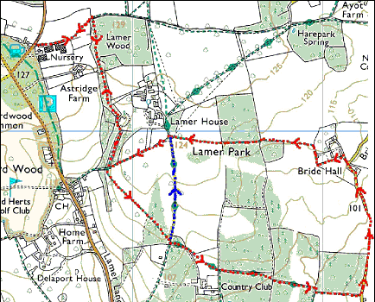

This mapping data licensed from Ordnance Survey® © Crown copyright 2007.
All rights reserved, licence number 100046670

The jug, top left, represents The Cross Keys pub, the start of the walk.
For the long walk, follow the red arrows.
For the short walk, follow the red arrows until they meet the blue arrows, then follow the blue arrows until they meet up again with the red arrows. Follow the red arrows after that.
The green diamonds along the avenue leading up towards Ayot St Lawrence represent part of Hertfordshire Way not included in the Snowdrop Walk.

Cross Keys to Lamer Wood

GR 175 165 to 178 166

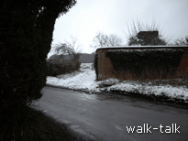
We go over to the pub sign, and cross the road aiming for the left hand end of the high brick wall.

High brick wall opposite the Cross Keys
GR 175 165

We go over the stile, noting the little draw-up gate for dogs to go through. It reminds me of a sluice gate at a water mill. Imagine how easy it is to get a lead tangled as the dog goes through.
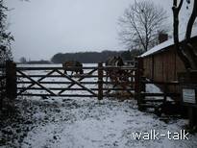
The nursery wall is on our right and a three-barred fence on our left beyond which is a paddock with horses. The wall changes from brick to breezeblock and then breezeblock with plaster flaking off, then a bit more brick. We can see glasshouses behind the wall. Ahead of us is the woodland where the snowdrops are.
There is a fig tree hanging over a brick bit of the wall and then there are small gable ends in the wall as if there used to be buildings going off away from us. Note that the breezeblock has a brick topping. I wonder if that was added later or whether it is needed because breezeblock is too porous to front the rain.

At the end of the wall, we go over the stile ahead of us, then to the left of the shed following the line of the fence on our left.
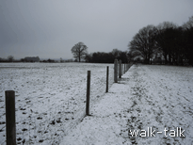
The fence is of wooden posts with a square-holed mesh of wires between. Do not miss the long views ahead of us to the left.

Fence line
GR 177 165

At the end of the fence, in an extended corner of the field, we go over a stile
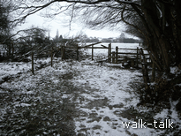

Extended corner of the field
GR 178 166

Before we turn right over the stile, if we look ahead we can see a quagmire. For those who know the area, the obvious route back is along the footpath ahead but because it is such heavy going – and because there is a putative bull in the field beyond - we shall retrace our steps through Lamer Wood and give ourselves a second look at the snowdrops.

North to South through Lamer Wood

GR 178 166 to GR 179 158.
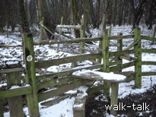
We turn at 90 degrees away from the quagmire and go over the second stile into woodland.

Two stiles, the second is to the right
GR 178 166

We need to watch our footing here as the path slopes down.

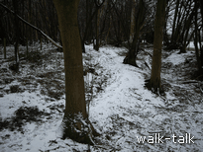
There are interesting dips and mounds on either side of us. The dip on the right might have been lime pit where lime was extracted and treated to be spread on the fields.

Mounds at the north end of Lamer Wood
GR 178 166

Note, too, the distortion of the trees along the edge of the wood to the right. The horizontal lie of the trunks shows that the trees formed a laid hedge. At the time it would have made an almost impenetrable barrier between the wood and field and would have provided cover for small animals like field mice and hedgehogs.

The trees are mostly hornbeams. The faint vertical striations identify them. They are the trees that provide the best quality charcoal. “Hertfordshire gold”, the hornbeam is called because most of the charcoal burnt in London hearths in the seventeenth, eighteenth and nineteenth centuries came from woodland like this and was an important source of revenue.

We can also see a few white trunks of silver birches or deep grooves of oaks.

Try to keep to the path. If you look closely you can see the beginnings of bulb shoots underfoot. It is tempting to meander away from the sticky main track but eventually we would destroy all the new growth.

We go over what was a stile but is now no more than a horizontal bar.
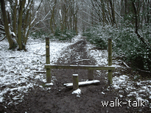
Stile no more than a horizontal bar
GR 178168

To our left, the woodland soon gives way to open meadow. All this land is part of the Lamer estate. More of that later.

Keep an eye open for dark green brambles that go in a line from left and right of the path. There is a patch of snowdrops on the far side of the brambles on the right. It is easy to miss them.

As the woodland extends again on our left, there is a double line of yew trees with a significant ditch between them. It runs to our left but there is little sign of it to our right. I wonder if it was a boundary marker at one time.
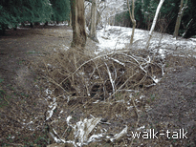

Ditch between yews
GR 178 162

Now we are closer to the fence on the left and the path is squelchy.

Soon, on the right, we can see a few quiet snowdrops. “Quiet” because they are small and almost dull, and “quiet” also because they seem for some reason to add to the calm stillness of the wood. In my book of Wild Flowers of Britain by Roger Phillips, the snowdrop is called “Flower of `Hope`”,with a capital H for Hope. It is of the family Amaryllidacceae, a “bulbous perennial probably native”.

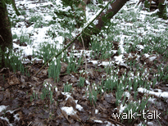
Snowdrops in the snow
GR 179 162

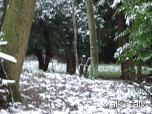
The path curves round to the right. If you tread carefully closer to the thick green laurels on the left and look across and down to a small hollow, you can see that there is almost a little valley of snowdrops in the grass.

Snowdrops in the grass
GR 179 162

There are snowdrops under the trees on the right and a few to the left for quite a way.
On one of the Woodland Trust family of Websites, http://www.naturedetectives.org.uk, I found a table of days after 31 December that the first snowdrops were seen in the years from 1960 to 2000. It goes from 56 days to 25 days: the end of February in 1960 to late January in 2000. That is in Newcastle. The Norwich data goes from 1970 to 2000, and has a less consistent trend downwards: 22 days in 1970, -1(30th December) in 1990, 10 in 1995 and 8 in 2000. Here in Lamer Wood, Hertfordshire, in 2007, the snowdrops were up and out by 24 January. It is said to be a particularly warm January, but the snowdrops did not look as if they had been out long.
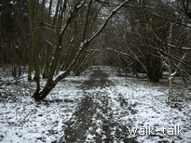
The path continues
GR 179 159

We continue on the path to a stile at the end of the woodland. The stile is in a poor state of repair but there are good steadying posts. There is wild clematis growing to the right of the stile. In sunshine its seeds, “old man’s beard”, glow silver in a most attractive way.

Lamer Drive to the Hertfordshire Way

GR 178 158 to 182 155

We are on a private asphalt road. We want to go straight across it over the stile into a meadow but before we do, we want to turn right round and note the stile we have just negotiated because we shall be coming down the asphalt road and want to turn right over that same stile to retrace our steps to the pub.

To the right of the stile into the meadow, there are some snowdrops under the trees at the top of the garden of the house below.

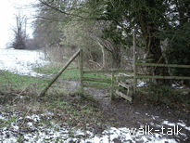
Stile leading into the meadow
GR 178 158

Over the stile, we follow the direction of the yellow footpath waymark arrow: uphill slightly left across the meadow, making for the mid point of the woodland ahead.

There is no mistaking the path etched into the grass as we head up across the meadow aiming for the midline of the woodland ahead. There is a picturesque little copse on the left, mostly pine, at least one Scots pine.

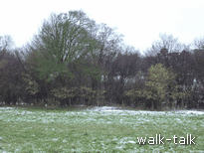
There is an excellent far view ahead and slightly right. We are heading southwest and Wheathamstead, Sandridge and St Albans are due fractionally east of south.

On the right hand edge of the meadow there are some bright cheery yellow hazel catkins: another hopeful sight for us in mid winter, as if the tree by the catkins which is green astonishingly early. I do not know what tree it is.

Catkins and a spring-green tree
GR 179 157

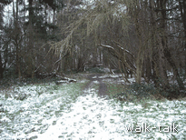

We go under larches into the woods ahead along a clear path continuing in the direction we have been walking.

Underneath the larches
GR 181 156

We come to a large house with out buildings on our right and cross a stile on to a track, part of Hertfordshire Way.

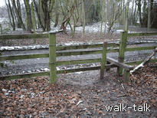
The stile leading on to Hertfordshire Way
GR 182 154

This is all part of the Lamer estate which belonged to the Garrard family. I have heard the second syllable of the name pronounced “rid” rather than to rhyme with “hard”, and the G soft as in George. The last of the Garrard family had no male issue and the land was inherited by Major General Cherry, known locally as “The General”. The estate he inherited was valued at a sum that is the equivalent of six million pounds today. The land here was of 20 square miles but there was other land in this country and abroad. The General’s only son, Apsley Cherry-Garrard went with Scott to the Antarctic in 1912. More of him another time. I think The General is interesting enough. He was born in 1835, a younger son who served in the army in India and in South Africa from where he wrote to his brother of the terrible slaughter that he was caught up in. At the age of 50 he returned home and married a doctor’s daughter, 25 years his junior. They settled in a modest red-brick house in Bedford and started to make babies.
Then his elder brother died unexpectedly and The General inherited the family estates in Buckinghamshire. Then his mother’s brother’s widow died and he inherited Lamer and other estates on condition that he took the name Garrard. Within less than he a decade he had come from living in a street to being a rich and important land owner.
The house that The Gereral and his wife moved into was an elegant 18th century neo-classical mansion, now long gone. The servants liked it that The General and his wife shared a bed: They said that it made them more human. They had five children, four girls and the boy, Apsley. Apsley lived on into 1959 and I like to think of this amazing link between father and son spanning more than a century from the time of William IV and nothing but horse-drawn traffic to the after the launch of the first sputnik.

For the short walk, go left on the track to the asphalt drive we crossed from the woods to the meadow and go left, picking up the walk at “Lamer Drive corner to The Cross Keys. GR 182 159 to 175 165”

Hertfordshire Way to Bride Hall Lane

GR 182 155 to 192 152

To continue for an interesting loop that passes Bride Hall, we go right along the track (part of Hertfordshire Way) for about 20 yards to a gate on the left with yellow footpath waymarks.
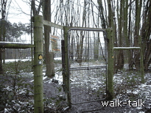
Gate
GR 182 154

We go through the gate, noticing the hook and loop that need to be reconnected when we are through and continue much in the direction we were walking through the meadow and woods: southwest. There is no mistaking the path.

We are on the golf course of Lamer Country Park. The Tee is to the right and the balls should be flying away from us but do keep a look out because a speeding golf ball is dangerous. Golfers will be aiming for greens, which have flags on them.

The Lamerpark Country Park caters particularly for Japanese visitors. I wonder if the players are mostly people over in Britain for other reasons or whether they fly here especially for the golf, which I understand is popular but expensive in Japan.

The scene opens up ahead of us to the left and to the right to a line of larches across the golf course. We are in amongst Scots pines with their attractive mauve and pink bark on straight proud trunks.

There is snow on the ground on the day I am walking, I wonder if the course is open because the frozen grass blades on the greens are easily damaged. With the white of the snow, they would have to play with red balls. I jump as I hear the crack of what I assume is club against ball but see is the crackle of spit of a controlled fire burning to the right. The smoke puthers up from it in an old-world way.

We see a waymark post as we come out into the open and a track merges with ours from the right .
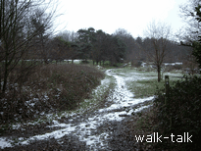
Track merges from the right
GR 183 153

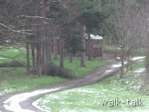

We bear left towards a brown wooden shed-cum-summerhouse.

Wooden shed/summerhouse
GR 183 153

We can see the ranch-style clubhouse buildings to our right. We are on a track rather than a path now.

A hot toddy at the shed would be welcome, but all we get is a, perhaps reassuring, sign that we are on the Hertfordshire Way.

There is a tricky bit coming up. The track curves to the left at a sign, gold on green, saying that the 10th tee is away in one direction and we want to go in the opposite direction. The practise range is to the left and we want to go straight on.
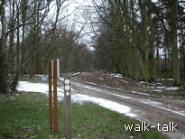
The track curves left but we go straight on
GR 185 152

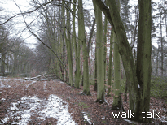

We look for a short footpath waymark post and head for it. There is a distinctive straight row of tall beech trees lining the right of the path.

Distinctive line of beech trees
GR 185 152

There is woodland to the left and we are on a good wide track.
I feel that if the Greenlanders have hundreds of different words for snow, we in Britain should have developed words to distinguish the different kinds of mud. It is not what I would call claggy underfoot here: it is a shallower slippier kind of mud.

The sun is beginning to come out after what was a heavy snowladen sky. The sun is now on the trees to our right and shines them to life.

At the end of the distinctive line of beeches, look for the footpath waymark and make for it, keeping straight on rather that curving left on the main track.

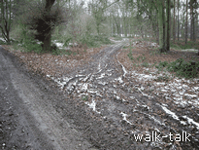

Again, the track curves left
but we go straight on
GR 187 152

There is soon another footpath waymark and Hertfordshire Way sign, taking us a bit to the left. We are walking more west than southwest now. There is woodland on either side of us with bramble undergrowth.

We head towards short white posts with a chain-effect between them.

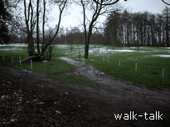
White posts with chain-effect between them
GR 188 152

Golf tee number 9 is on our right. We follow the direction of the yellow footpath waymark arrow: slightly to the right, aiming for the nearer woodland.

There is a flag on the green to the right so beware.

At the end of the woodland the path curves round to a gate into a field.
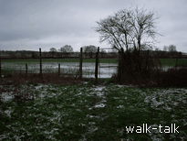
Gate into a field
GR 190 152

We need to go through the gate but will NOT follow the waymark arrow or the Hertfordshire Way sign but go left along the top of the field so that woodland is on our left and field is on our right.

Although not marked at the gate, there is a clear footpath sign at the far end showing that we are on a legitimate path.
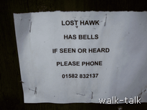
By the gate is a notice that tells a story:

An interesting notice
GR 190 152

There are a crowd of large black birds in the field. I assume they are rooks: “a crow in a crowd is a rook”. I have seen such groups go wheeling up together when disturbed, but this lot lazily headed for the trees. Perhaps that means that they are not rooks.

We come out into Bride Hall Lane just north of its junction with Codicote Road.

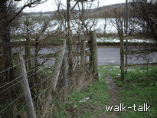

From field to Bride Hall Lane
GR 192 151

Bride Hall Lane from Codicote Road to the tradesmen’s entrance to Bride Hall

GR 192 151 to 192159

We are on Bride Hall Lane, just north of its junction with Codicote Road. We turn left into Bride Hall Lane and walk up it to the Bride Hall tradesmen’s entrance: not the first set of brick-edged wrought iron gates, but the second.

The road is narrow and winding and dangerous. Beware!

We are going uphill and the banks and hedges mean no view but the near one. Taking note of the hedges on either side of Bridge Hall Lane might keep you going.

The high banks and hedges probably denote a drover’s way. It would be helpful if the beasts were not able to roam off. Not only beasts were driven, I have heard tell of the feet of geese being painted with tar or fitted with little leather boots before setting out on the long walk to London. You can picture them with their cocky heads turning left then right to see forwards, grumbling to each other as they do a more-stately-than-waddle walk walk walk all that way.

The rule of thumb is that you can tell the age of a hedge by the number of species in it minus one so when you feel yourself flagging, count the species within each 100 paces and work out the age of the hedges. Let me know. To confuse future enthusiasts, we now tend to plant multi-specied hedges but the hedges along Bride Hall do not look new.

On the right the hedges have been cut above and along the road by a machine which looks as if it rather tears the branches. At the Royal Horticultural Gardens of the Rose, they did an experiment to find which was the best kind of pruning. As a control, they did some gross pruning by machine and those beds were a mass of flowers compared to the other beds of more carefully, hand-pruned roses.

Certainly, hedge laying, which consists of drastic cutting and bending of the uprights, lengthens the life and strengthens the growth of foliage. Hedge laying creates, too, a low protective shelter for small animals that aid the eco-system. It is interesting to note that the hedge on the right has a layer of dried grass that is providing something of the same protection. On the left, by contrast the hedge is absolutely bare at the bottom providing no cover at all for little creatures.

I am lucky enough to be distracted by a large plump bird, not a cock pheasant, which I would have a hope of recognising. It took a great deal of flourishing and fluttering to make it up and over the road. Then unlucky enough to be passed by a dust cart.

We soon see the brick wall by the Bride Hall main entrance. Do you feel the arches in it are evocative of Moorish Spain? I think the fastidious Moors would flinch. On we go, following the arrow to the tradesmen’s entrance. We know our place.

There is a pleasant pair of brink houses on the right. They are part of the Bride Hall estate.

The entrance we want is round the bend opposite the second of the pair of brick semis. As the main gate it is wrought iron with brick on either side.

Bride Hall to Lamer House

GR 191 158 to 182 159

We can see the footpath sign so that we know we want to go through the wrought iron gates but it looks as if there is no way through.

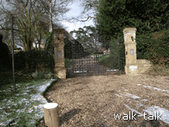
The tradesmen’s entrance to Bride Hall
GR 191 158

We look for the board that says “wicket gate” and underneath it is a handle.

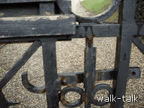

The handle of the wicket gate
GR 191 158

Press the hook at the end of the handle firmly down and push with some force on the wicket gate and it will open against a spring. We go through and make sure that the wicket gate clicks shut properly with the latch in its cradle behind us.

There is a beautiful cedar ahead of us and superb holly on our right. It is lovely to see the snowdrops on the bank to our left. It is as if they are on display for us.

We go ahead to the near end of the black-painted weather-boarded barn and there go left.

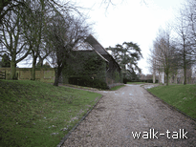
The weather-boarded barn before which we go left
GR 191 158

As we come to the end of the low fence on our left on to level ground, it is worth pausing. We are under a beech and there is a small exquisite beech to our left. We can see that there will be daffodils soon in the grass with a copse of silver birches beyond them. There is a low box hedge that forms a dolls’ avenue up the drive. If we twist round we can see that the drive leads to the gates of the Hall. It is a lovely house and the courtyard in front of it, formed by barn-like buildings on each side and our wall at the end, has a good feel.

We do not want to disturb their privacy today by gauping, so that it is worth knowing that we can look out in the paper for the Bride Hall charity garden open day. The gardens are magnificent and natural by turns, and we are welcome then to gaze to our hearts’ content.

As we turn back to look away from the house into the distance we have a marvellous view southwards. There is a line of larches ahead and to the right. We know those larches.

As we continue on our way, we pass along a hedged brick wall with a pretty tiled roof above it.

We pass black painted gates and then over a stile to continue with a well-patterned wall on our right.
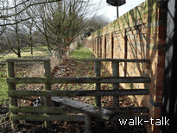
Stile and well-patterned wall
GR 191 158

We have to watch our head on the overgrown plants coming over the wall.
We go over the stile at the end of the wall and go right. It is all clearly marked.
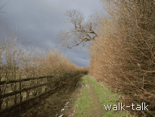

Going right at the end of the patterned wall
GR 191 158

There are hazel catkins at first on both sides. There are lovely birds playing in the hedges here. I am getting flashes of bright yellow as well as fawn and brown.

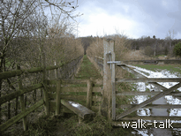
The track curves round to the left and there is a double gate.

Stile to the left of a double gate
GR 190 159

We want to be on the left to go over the stile. There is a lot of water and the left looks least inviting but there we go.

Now the path is lined with dog roses. There are a few wizened rose hips left untouched by the birds. Over our left shoulders is that marvellous long view south.

To the right is an area of the garden deliberately landscaped to be wild. On a visit to the gardens, distinct furrows and long humps can be seen radiating outwards towards the avenue of limes that we can see ahead and to the right. The humps shed rainwater down into the furrows which channel the water down to fall into ponds in the garden. The fan of the lines of humps and furrows also gives a wide pleasing effect.

The lime avenue links Lamer House to Ayot St Lawrence, coming out by the New Church. The Bernards Shaws and Cherry Garrards joined each other on Sundays for many years, GBS helping greatly in the writing of The Worst Journey in the World, which tells of Apsley Cherry Garrard’s winter trek across the Arctic to fetch penguin eggs. GBS would ask such questions as “What exactly is an ice flow?” which prompted Cherry to include such descriptions in his book. I am sure he helped in many ways through discussions and questions to make the book the literary masterpiece that it is.

There is no doubt about the route because it is closely fenced. We are taken through woodland where we need to beware logs over the path.

It is tempting to look up at the trees and not watch your feet: not that I would in general advocate missing the scenery to watch your feet. The larches are, to me, surprisingly straight, here. I think of larches as being unable to hold up their heads. On the right, there is a wider variety of trees. The trees do not have the characteristically deep hard crusty bark of an oak but judging by the leaves on the ground, there are oaks.

The mud here is of the slidy-combined-with-leafmould variety. Look on shelves shortly for “Mrs B’s Feeling for Mud”. It needs to be a thriller to compete with “Miss Smilla’s feeling for Snow” but I am sure we can think of something.

We go over the stile at the end of the woods, keeping in the same direction, west, across the clear grassy track underneath the power lines, following the arrows on the footpath waymarks.
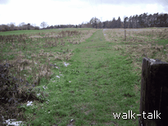

The clear grassy track from the larch wood
GR 185159

Note that we are on the golf course and need to be aware of where the golf balls will be coming from, watching out for golfers and noting what they are doing.

We come out on to an asphalt road, Lamer Drive, at the meeting point with the short walk.

Lamer Drive corner to The Cross Keys

GR 182159 to 175165

We go left along the asphalt road.

Lamer House in on our right behind the superb beech hedge that holds its warm tawny leaves right through winter. The farmhouse-cottage-style house is pretty and is not the majestic mansion that The General and his wife moved into. That is now long gone, pulled down to make way for this more homely number.

Near the bottom of the hill, we look out for the stile that is the south entrance to Lamer Wood. It is the one we came over as we left the snowdrop wood. It is on the right with old man’s beard all over the brambles.
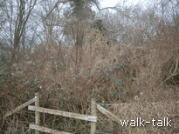
South entrance to Lamer Wood
GR 178 158

We go over the stile and start retracing our steps through Lamer Wood, enjoying again the snowdrops and woodland.

We go over the stile at the end of the woods, and immediately over the stile on our left to take us across a paddock and over yet another stile, then alongside the nursery and out on to the road opposite the Cross Keys.

