Map

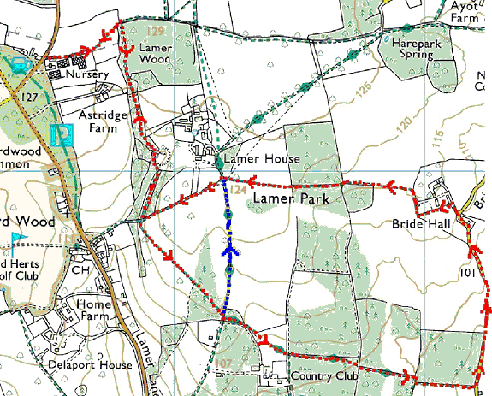

This mapping data licensed from Ordnance Survey® © Crown copyright 2007.
All rights reserved, licence number 100046670

The jug, top left, represents The Cross Keys pub, the start of the walk.
For the long walk, follow the red arrows.
For the short walk, follow the red arrows until they meet the blue arrows, then follow the blue arrows until they meet up again with the red arrows. Follow the red arrows after that.
The green diamonds along the avenue leading up to Ayot St Lawrence, represent part of Hertfordshire Way not included in the Snowdrop Walk.

To see snowdrops growing wild in woodland is a rare treat. This walk has a short route (2¼ miles) or a long route (4 miles/2 hours). Wear wellies or proper walking boots to cope with mud.

We start at The Cross Keys pub, which is between Wheathampstead and Kimpton. To get there from St Albans, we go out of town on Sandridge Road, which becomes St Albans Road, Sandridge, beyond the traffic lights at the King William IV. We go through Sandridge and Wheathampstead and straight across the roundabout at the far end of Wheathampstead. We are on the B651. It is confusing that soon after Lower Gustardwood the B651 takes a 90 degree turn to the right. It is signed to Kimpton and Hitchin. This is the road we want to take. It is Ballslough Hill and, as we turn into it, The Cross Keys is on the left.

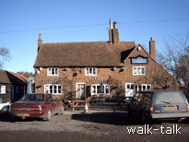
Cross Keys pub
TL 175 165

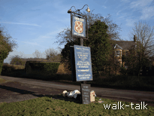

Cross Keys pub sign
TL 175 165

The Cross Keys does bar food and is willing for a group of up to 5 cars to be left in the pub car park while we walk. It is best to park away from the pub entrance, given that we shall be taking up the space for an hour or two.

1. Cross Keys to Lamer Wood

TL 175 165 to 178 166

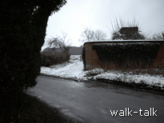
We go over to the pub sign, and cross the road aiming for the left hand end of the high brick wall.

High brick wall opposite the Cross Keys
TL 175 165
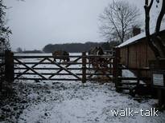

We go over the stile.
Stile by the high brick wall
TL 175 165

At the end of the wall, we go over the stile ahead of us, then to the left of the shed following the line of the fence on our left.

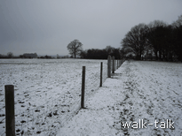
Fence line
TL 177 165

Ahead of us is the woodland where the snowdrops are.

At the end of the fence, in an extended corner of the field, we go over a stile
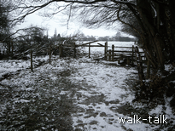

Extended corner of the field
TL 178 166

2. North to South through Lamer Wood

TL 178 166 to TL 179 158.
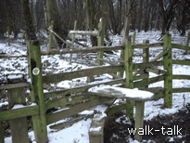
We turn at 90 degrees away from the quagmire ahead and go over the second stile into woodland.

Two stiles, the second is to the right
TL 178 166

We need to watch our footing here as the path slopes down.

We follow the path through the woods and go over what was a stile but is now no more than a horizontal bar.

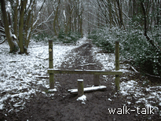
Stile no more than a horizontal bar
TL 178168

Keep an eye open for dark green brambles that go in a line from left and right of the path. There is a patch of snowdrops on the far side of the brambles on the right. It is easy to miss them.

Soon, on the right, we can see more snowdrops.

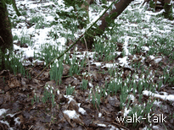
Snowdrops in the snow
TL 179 162

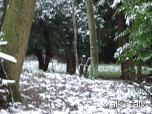
The path curves round to the right. If you tread carefully closer to the thick green laurels on the left and look across and down to a small hollow, you can see that there is almost a little valley of snowdrops in the grass.

Snowdrops in the grass
TL 179 162

There are snowdrops under the trees on the right and a few to the left for quite a way.

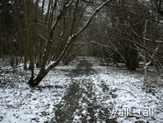
We continue on the path to a stile at the end of the woodland.

The path continues
TL 179 159

3. Lamer Drive to the Hertfordshire Way

TL 178 158 to 182 155

We are on a private asphalt road. We want to go straight across it over the stile into a meadow but before we do, we want to turn right round and note the stile we have just negotiated because we shall be coming down the asphalt road and want to turn right over that same stile to retrace our steps to the pub.

To the right of the stile into the meadow, there are some snowdrops under the trees at the top of the garden of the house below.

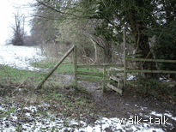
Stile leading into the meadow
TL 178 158

Over the stile, we follow the direction of the yellow footpath waymark arrow: uphill slightly left across the meadow, making for the mid point of the woodland ahead.

There is no mistaking the path etched into the grass as we head up across the meadow aiming for the midline of the woodland ahead. There is a picturesque little copse on the left, mostly pine, at least one Scots pine.

There is an excellent far view ahead and slightly right. We are heading southwest and Wheathamstead, Sandridge and St Albans are due fractionally east of south.

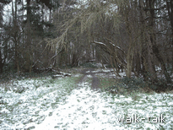
We go under larches into the woods ahead along a clear path continuing in the direction we have been walking, southeast.

Underneath the larches
TL 181 156

We come to a large house with out buildings on our right and cross a stile on to a track, part of Hertfordshire Way.

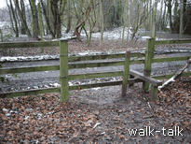
The stile leading on to Hertfordshire Way
TL 182 154

For the short walk, go left on the track to the asphalt drive we crossed from the woods to the meadow and go left, picking up the walk at
“7. Lamer Drive corner to The Cross Keys. TL 182 159 to 175 165”

4. Hertfordshire Way to Bride Hall Lane

TL 182 155 to 192 152

To continue for an interesting loop that passes Bride Hall, we go right along the track (part of Hertfordshire Way) for about 20 yards to a gate on the left with yellow footpath waymarks.
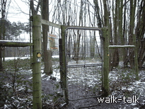
Gate
TL 182 154

We go through the gate, noticing the hook and loop that need to be reconnected when we are through and continue much in the direction we were walking through the meadow and woods: southeast. There is no mistaking the path.

We are on the golf course of Lamer Country Park. The Tee is to the right and the balls should be flying away from us but do keep a look out because a speeding golf ball is dangerous. Golfers will be aiming for greens, which have flags on them.

We see a waymark post as we come out into the open and a track merges with ours from the right .

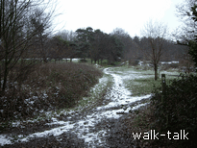
Track merges from the right
TL 183 153

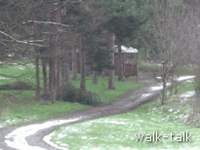

We bear left towards a brown wooden shed-cum-summerhouse beyond the trees ahead.

Wooden shed/summerhouse
TL 183 153

We can see the ranch-style clubhouse buildings to our right beyond a car park. We are on a track rather than a path now.

There is a tricky bit coming up. The track curves to the left at a sign, gold on green, saying that the 10th tee is away in one direction and we want to go in the opposite direction. The practise range is to the left and we want to go straight on.

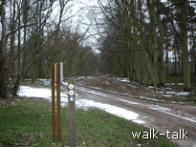
The track curves left but we go straight on
TL 185 152

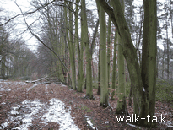

We look for a short footpath waymark post and head for it. There is a distinctive straight row of tall beech trees lining the right of the path.

Distinctive line of beech trees
TL 185 152

There is woodland to the left and we are on a good wide track.

At the end of the distinctive line of beeches, we look for the footpath waymark and make for it, keeping straight on rather that curving left on the main track.

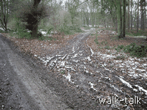

Again, the track curves left but we go straight on
TL 187 152

There is soon another footpath waymark and Hertfordshire Way sign, taking us a bit to the left. We are walking more east than southeast now. There is woodland on either side of us with bramble undergrowth.

We head towards short white posts with a chain-effect between them.

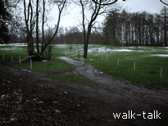
White posts with chain-effect between them
TL 188 152

Golf tee number 9 is on our right. We follow the direction of the yellow footpath waymark arrow: slightly to the right, aiming for the left-hand end of the nearer woodland.

There is a flag on the green to the right so beware.

At the end of the woodland, the path curves round to a gate into a field.
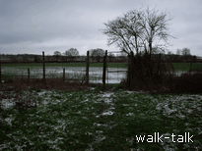
Gate into a field
TL 190 152

We need to go through the gate but we do NOT follow the waymark arrow or the Hertfordshire Way sign. We go LEFT along the top of the field so that woodland is on our left and field is on our right.

Although not marked at the gate, there is a clear footpath sign at the far end showing that we are on a legitimate path.

We come out into Bride Hall Lane just north of its junction with Codicote Road.

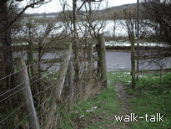

From field to Bride Hall Lane
TL 192 151

5. Bride Hall Lane from Codicote Road to the tradesmen’s entrance to Bride Hall

TL 192 151 to 192159

We are on Bride Hall Lane, just north of its junction with Codicote Road. We turn left into Bride Hall Lane and walk up it to the Bride Hall tradesmen’s entrance: not the first set of brick-edged wrought iron gates, but the second.

The road is narrow and winding and dangerous. Beware!

The entrance we want is round the bend opposite the second of the pair of brick semis. As the main gate it is wrought iron with brick on either side.

6. Bride Hall to Lamer House

TL 191 158 to 182 159

We can see the footpath sign so that we know we want to go through the wrought iron gates but it looks as if there is no way through.

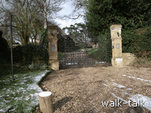
The tradesmen’s entrance to Bride Hall
TL 191 158

We look for the board that says “wicket gate” and underneath it is a handle.

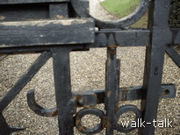

Press the hook at the end of the handle firmly down and push with some force on the wicket gate and it will open against a spring. We go through and make sure that the wicket gate clicks shut properly with the latch in its cradle behind us.

The handle of the wicket gate
TL 191 158

There are snowdrops on the bank to our left, undoubtedly cultivated but no less attractive for that.

We go ahead to the near end of the black-painted weather-boarded barn and there go left.

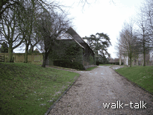
The weather-boarded barn before which we go left
TL 191 158

As we come to the end of the low fence on our left on to level ground, it is worth pausing to take in the long view south and the near view of the box-hedge lining the drive up to the house, the house itself and the trees, barns, and gates.

In the summer there is a charity open day to Bride Hall gardens.

We pass black painted gates and then over a stile to continue with a well-patterned wall on our right.

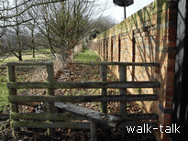
Stile and well-patterned wall
TL 191 158

We have to watch our head on the overgrown plants coming over the wall.

We go over the stile at the end of the wall and go right. It is all clearly marked.

The track curves round to the left and there is a double gate.
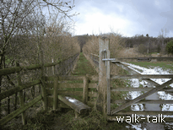
Stile to the left of a double gate
TL 190 159

We want to be on the left to go over the stile.

There is no doubt about the route because it is closely fenced. We are taken through woodland where we need to beware logs over the path.

We go over the stile at the end of the woods, keeping in the same direction, west, across the clear grassy track underneath the power lines, following the arrows on the footpath waymarks.

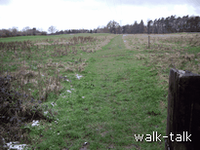
The clear grassy track from the larch wood
TL 185 159

Note that we are on the golf course and need to be aware of where the golf balls will be coming from, watching out for golfers and noting what they are doing.

We come out on to an asphalt road, Lamer Drive, at the meeting point with the short walk.

7. Lamer Drive corner to The Cross Keys

TL 182 159 to 175 165

We go left along the asphalt road.

Lamer House in on our right behind the superb beech hedge.

Near the bottom of the hill, we look out for the stile that is the south entrance to Lamer Wood. It is the one we came over as we left the snowdrop wood. It is on the right with old man’s beard all over the brambles.
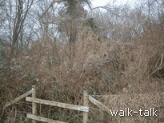
South entrance to Lamer Wood
TL 178 158

We go over the stile and start retracing our steps through Lamer Wood, enjoying again the snowdrops and woodland.

We go over the stile at the far end of the woods, and immediately over the stile on our left to take us across a paddock and over yet another stile, then alongside the nursery and out on to the road opposite the Cross Keys.

