Snowdrop Walk

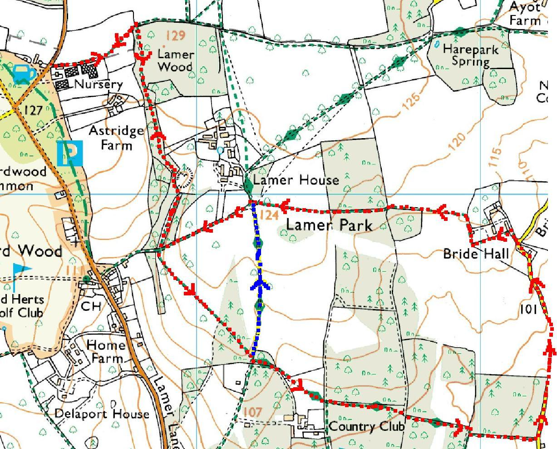

This mapping data licensed from Ordnance Survey® © Crown copyright 2007.
All rights reserved, licence number 100046670

The jug, top left, represents The Cross Keys pub, the start of the walk.

For the long walk, follow the red arrows.

For the short walk, follow the red arrows until they meet the blue arrows, then follow the blue arrows until they meet up again with the red arrows. Follow the red arrows after that.

The green diamonds along the avenue leading up towards Ayot St Lawrence represent part of Hertfordshire Way not included in the Snowdrop Walk.

