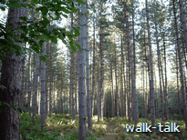
Introduction
There is an interesting sculpture trail in the middle of this walk but it is the peace and tranquillity of the woodland that is its essence.

The walk starts from The Woodman pub in Wormley West End, goes north through fields and woodland to Broxbourne Woods Sculpture Trail and makes its way back by a part-different route.

Most of the way we are on the National Nature Reserve Trail, clearly marked by butterfly waymarks. There are no steep inclines and, except for small patches of mud round gates in a farm, the surface underfoot is good: particularly so round the sculpture trail.

Distance: 4 miles
Underfoot: sometimes a quagmire at one farm gate
Inclination: gentle
Nature: woodland and meadow
Interest: sculptures, tranquillity

To get to The Woodman, NGR TL 337 060:
- From the A414 going east towards Hertford, take the turning to Hertingfordbury.
- In Hertingfordbury, keep a close eye out for St Mary's Lane and turn on to it (straight on but left off the line of the road).
- At a T junction (B158 Lower Hatfield Road), go right and immediately left.
- You are in Broad Green. Keep going as the road changes its name to Bayford Lane and then Well-Row.
- At Bayford, go straight on into Ashendene Road, signed “Epping Green”.
- After a mile, at what is almost a T-junction, turn left into White Stubbs Lane.
- After a bit more than 2 miles along White Stubbs Lane, go right into West End Road.
- At the T junction go left into what is still West End Road and the pub is on your right.
- The Woodman, Wormley West End. (grid reference TL337060; telephone 01992 463719).

Refreshments
Refreshments are available at the start and finish of the walk at The Woodman, Wormley West End, Herts., EN10 7QN; NGR TL 337060; telephone 01992 463719. A range of beers and food, including Sunday roast dinners, is available.
Good fare is also to be found at The Bakers Arms, Ashendene Road, Bayford, Herts., SG13 8PX; NGR TL 310084 on the route from the A414 to Broxbourne Woods or The Woodman (see getting there).
Likewise at The Farmer's Boy 1 Brickendon Lane, Brickendon, Herts., SG13 8NU; NGR TL 323080; telephone 01992 511610; www.thefarmersboy.net; on the route from the A414 to Broxbourne Woods.

Map and brief description

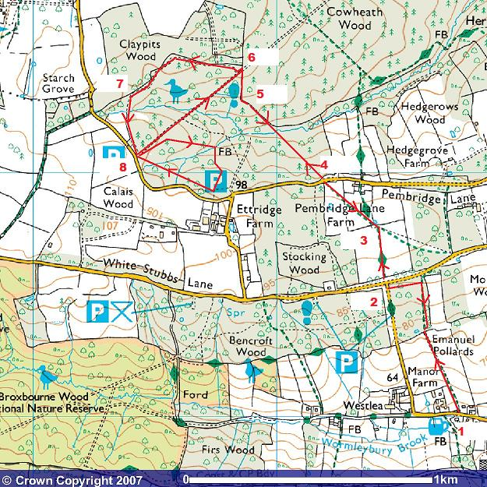

This mapping data licensed from Ordnance Survey® © Crown copyright 2007.
All rights reserved, licence number 100046670.
The jug, bottom right, with the red number 1 next to it, represents The Woodman pub, the start of the walk.
Follow the red arrows and the numbers in sequence to 8, then 8 through 6, 5, 4, 3 and 2 back to 1.
- From The Woodman (1), go through the gap in the hedge opposite “The Woodman” pub sign and head north through a short tunnel of trees into a field and then into woodland to pick up the National Nature Reserve Trail with its distinctive butterfly waymarks.
- Go right on to the butterfly trail and follow it to West End Road (2).
- Turn right and cross White Stubbs Lane into fields. Follow the butterfly trail until there is a choice (3) of butterfly trails, one route going straight ahead, and the other diagonally left. Take the one diagonally left.
- Go straight across Pembridge Lane (4) and follow the butterfly marks. The Trail joins (5) a trail marked by posts with a purple painted groove under the butterfly marks. There is one tricky part (6): where a bench appears ahead and on the right of the path. As you look at the bench, there is blue paint on the left side of its back. Go up to the bench then go left for about 10 yards and then right. A low post with a white top marks the correct combined purple and butterfly trails.
- Follow the direction of the combined waymark posts ONLY when they point ahead. IGNORE the one (7)pointing right and carry straight on on the purple-only trail. Follow it to Broxbourne Woods West Car Park (8).
- Follow the signs round the sculpture trail. Two low posts, each topped by a walking man in a white disk, mark the entrance.
- Back at the West Car Park take the wide clear track, almost a road, alongside and to the left of the entrance to the sculpture trail.
- Where a bench interrupts the straight track (the bench at the tricky bit (6) described above), go right to retrace your steps to The Woodman: re-join the combined purple and butterfly trails, then the butterfly-only trail, then left at the wooden sign to The Woodman (1).
4 miles

1 to 2: The Woodman to White Stubbs Lane

TL 337060 to TL 335065

We go through a gap in the hedge directly opposite The Woodman pub sign. This is the entrance to “Footpath 21 White Stubbs Lane ½”.

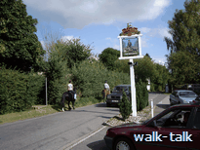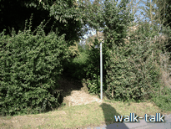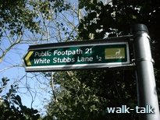
We are in a tunnel between hedges; pines on the right and and, on the left, seed-laden hornbeams and a steep ditch with some ancient hornbeams showing the distortions of long-ago laying.
We soon cross a stile on to a path fenced off from a meadow. To catch our breath as we climb the hill, we pause to savour the long views behind us.

At the top of the hill, we go through a metal kissing gate into Emanuel Pollards, a fragment of woodland on the east of West End Lane.

It is worth having a good look round at how it will look on the way back so that we can be sure to turn here: note the wooden sign pointing back to The Woodman and the strangely looped hornbeam branch above the kissing gate.

We go right following the direction of the butterfly waymark that we shall see a lot of now as it marks the National Nature Reserve (NNR) trail that we shall be following.

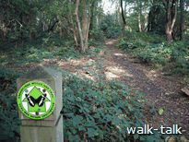
We go right, following the direction of the butterfly waymark.
We are in coppiced hornbeam woodland with a carpet of autumn leaves at our feet.
The faint grey upwards striations on the bark and the horizontal lift of the fine branches identify the hornbeam.

The path bears left so that we are walking along the eastern edge of the woods and can see, beyond the edge of the tree line, a meadow - and beyond the meadow, a magnificent bank of trees.
There is a dry pond on our right, between the path and the edge of the wood.
Soon after the dry pond we come, on the right hand side of the path, to a wooden board (TL 336065). It is facing the wrong way for us to read what is on it.
As we pass it, we read “Emanuel Pollards” and some more information about these woodlands. We see, also, the next butterfly waymark, which points us to the left.
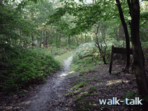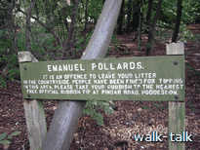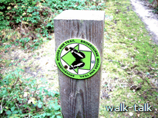
We are walking west now, close to White Stubbs Lane, which is on our right. Very soon there is another reassuring butterfly waymark.
We come out on to West End Road, which runs to our left. White Stubbs Lane is on our right.
We have reached point 2 on our map TL 335065.

2 to 3: White Stubbs Lane to where the paths diverge

TL TL 335065 to TL 335 068
We come out on to West End Road, which runs to our left. White Stubbs Lane is on our right.
We stay on this side of West End Road and go right, straight across White Stubbs Lane and on to a footpath “Public Footpath 25, Pembridge Lane ¼”.

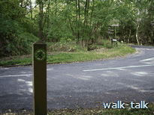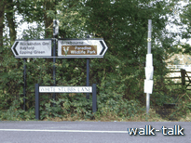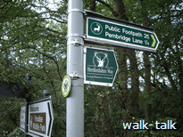

We go over a wooden bridge to a proper wooden kissing gate and out into a field. A butterfly waymark confirms the direction we should take.
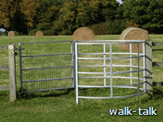
We can see the metal kissing gate we need to aim for.

Through it, we are into a meadow. We keep on in the same direction making for the dent in the high tree line ahead.
It is a mistake to aim for the more obvious gap in the bushes lower down: we want to be left of that.
What we are looking for is a kissing gate that is hidden behind blackthorn bushes

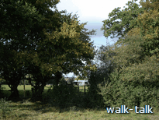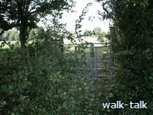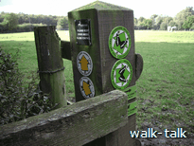

To the left of the metal kissing gate is a wooden post on which we can see the butterfly and yellow footpath waymarks showing that there are rights of way going off in two directions from here. This is useful to pinpoint your position on a map.

This parting of the ways is point 3 on our walk.

3 to 4: From where the paths diverge to Pembridge Lane Crossing

TL 335068 to TL 332070

We fork left.

We are into a paddock with ponies and cows. There is a substantial metallic-looking animal shelter ahead and to the right.

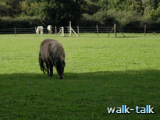
We aim for the metal kissing gate ahead and to the left.

We go through the metal kissing gate and keep in the same direction, diagonally across the field
making for a waymark post.

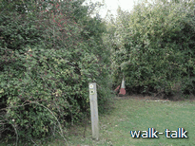

We go through a gap in the hedge over some wooden boards
with a metal netting cover and on and through a metal kissing gate.

Here we angle right.

There is a fenced area off to our left. There looks to be a scarecrow alongside the fence and then a bank. Behind the bank we can see the roof of what is a duck house. We aim for a waymark post to the right of the fence, and a metal kissing gate beyond the post.
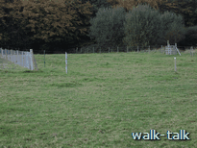
Through the metal kissing gate we bear left.

We come out on to a road. This is Pembridge Lane.
point 4 of our walk, TL 332070

4 to 5: Pembridge Lane to join the purple trail

TL 332070 to TL 328073

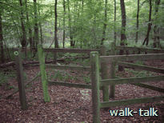
We go across the road at the angle we have been walking and go through a wooden kissing gate with our friendly butterfly into woodland.

The path takes us a bit rightwards.
Soon we pass a yellow arrow waymark with the number 5 in it.
Now we are on to boards covered in wire netting.
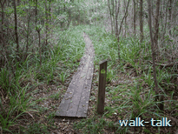

After the boards, we keep straight until we see a butterfly waymark and a heap of logs ahead and on the left.
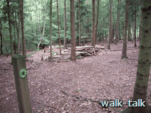
It is worth having a look round here because we shall be coming back this way and we want to be careful to retrace our steps rather than go on the path behind us to the left. It will be particularly tempting because we can see boards on the path similar to the ones we have just be walking on.
On the way back, the pile of logs will be our cue to fork left not keep straight on.

(If you want to take a short cut to Broxbourne East Car Park and the sculpture trail, turn hard left along that path on to the boards. The path comes out at Pembridge Lane. Go right along the bridle path that skirts the Lane and it will bring you to Broxbourne East Car Park.)

We pass on our right a pair of pine trees completely upended.

A bit further on there is only a yellow mark on a tree to reassure us and then more
boards to lift us above the mud and over a spreamlet - Spital Brook.

The path takes a right angled turn to the left. The post with the butterfly arrow is well to the right but a white spot on a tree ahead alerts us and the path is well worn.

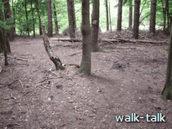
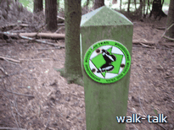

We are soon on to boards again.
We go over a watercourse.
The path curves right, well butterfly-marked, and we have a fence on our right and beyond it
the watercourse with a steep bank above it.

We come to two 2-barred bits of fence offset from each other. We go through and straight on.
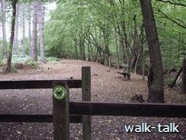
There is a bench on our right. Along the back of the bench on the right are distinctive
blue and white paint markings.
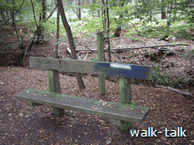
We have reached the point where we are joined by the purple trail. From here on we want to follow the joint purple and butterfly trails.

(If you go off to the left here and follow the purple trail, you travel south and then take a big loop east and then go west to the Broxbourne Wood East Car Park, a point on the Sculpture Trail.)

We are at point 5 on our walk.

5 to 6: from joining the purple trail to the top of the straight track

TL 329073 to TL 328074

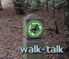
We are on the combined purple trail and butterfly trail. We can see the purple painted stripe beneath the butterfly sign on the waymark post beyond the bench.

The path now is a wide track with patches of asphalt.

As we follow the line of the watercourse on our right, the path curves right
and then straightens up to head due north for a bit.

We pass a roofed pile of timber and come to a butterly and purple trail waymark and then
a bench with blue paint on the left hand side of its back.

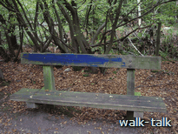
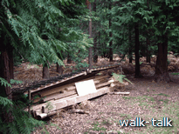
We have reached point 6 on our walk.
(If you go down the track to the left you come to Broxbourne Woods West Car Park, point 8, the start of the sculpture trail. We shall be coming back up the track on the way back.)

6 to 7: from the top of the straight track to leaving the butterfly trail

TL 328074 to TL 324073

It is a bit tricky here: we want to go about 10 yards left and then right.
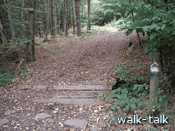
A blue and white stripe, topped by an arrow head, on a low post
is on the right hand side of the entrance to the track we want to take
and there is a blue and white stripe on a tree to the left.
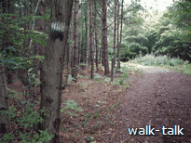
We head down the track and soon there is a combined butterfly and purple trail waymark.

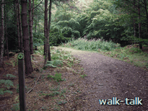

We curve left and follow the track as it takes us through ever-changing woodland and by the occasional bench. The track narrows but we are reassured by the occasional combined trail waymark pointing us straight on - ONLY when it points us straight on.
When the butterfly waymark points right, we have come to the tricky bit where we need to LEAVE the butterfly trail and carry straight on, on the purple trail,

We do NOT follow the combined trail where it points us to the right and where there is also a low bridleway waymark post with its distinctive blue arrow and the letters bridleway etched in blue.
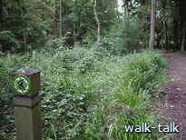
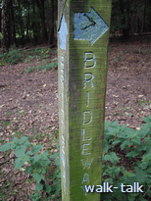
(If you do follow the butterfly trail and bridleway to the right, you come out on to Pembridge Lane a bit northwest of the Broxbourne Woods West Car Park. The butterfly trail goes on from there, bears south, crosses White Stubbs Lane and takes a huge loop through Wormley Wood and Bencroft Wood, gradually coming back up to where we joined it in Emanuel Pollards.)

Instead we DO go straight on.

We have reached point 7 on our walk: we are leaving the butterfly trail.

7 to 8: from leaving the butterfly trail to the sculpture trail

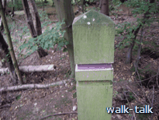
TL 324073 to TL 324071

Soon there is a waymark with only a purple stripe and we know we are going the right way.

We go down and across a watercourse with railings on either side.
We go up the other side and pass a double purple trail waymark.

We are close on our right to the edge of the woodland and see the bank and signs of a laid hedge along it.

Soon we come in to a car park.
We are at point 8 on our walk, the Broxbourne West Car Park and start of the Broxbourne Woods Sculpture Trail.

Sculpture Trail (8)- Broxbourne Wood West Car Park, round the sculpture trail and back again.

TL 324071 to TL 324071

The Sculpture Trail starts from Broxbourne Woods West Car Park.
We cross the car park and a track going to the left and go left on to a yellowy-white sanded path at least a metre wide. There is a post archway over it.
The entrance to the Sculpture Trail is marked by two low posts,
each topped by a walking man in a white disk.

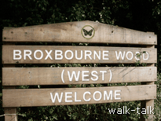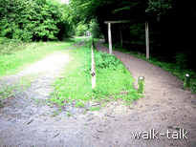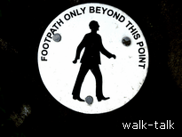

The trail is designed for disabled access and is hard underfoot. The trail is half a mile long and we go round it clockwise, keeping to the hard-surface trail until we reach the Broxbourne Wood East car park.

It is easy to miss the first sculpture of a peasant woman and child, a life size carving of a woman reaching up foraging for wild fruits, berries, nuts and fungi.

The next carving looks like a seat but is not. It represents a single winged hornbeam seed.

Then comes the wild boar and piglets. Then the pulley seat representing the hornbeam block and tackle used in shipping and by army engineers in World War II. Rifle butts were also made at that time from the hardwearing hornbeam wood.

After that is the charcoal burner, a blackened figure leaning on his shovel. Behind is a clamp, the carefully piled mound of harvested wood, which was lit and covered with earth so that it would burn very slowly and turn into charcoal.

We turn and go on to the acorn seat, then the Roman soldier, a bit off course for Ermine Street, the 200-mile long Roman road connecting London with York. Ancient pollards line the section of Ermine Street that cuts north to south through the woods a mile and a half north east marking the line between Broxbourne Woods and Hoddesdonpark Woods.
We come into Broxbourne Woods East Car Park.
(If you have had enough of it all, you can go left through the car park and keep going on the purple trail while it keeps close to, and parallel to, Pembridge Lane. Where the purple trail goes left away from the road at a bench, follow it over boards until you get to the pile of logs then turn back on yourself but a bit to the right, and follow the butterfly trail back to Pembridge Lane, point 4 on the map. You cross the road at a slight diagonal right, back into the field with the odd little hexagonal-roofed duck shelter. Retrace your steps to The Woodman.)
If you are coping, we continue on the sculpture trail to take in one more sculpture and another route back.
The last of the sculptures is a herder looking for his cattle – whose heads we can see behind him.

We are soon back at the Broxbourne Wood West Car Park, point 8, ready to go on up to point 6 on the map and back to The Woodman.

8 to 1 (via 6,5,4,3 and 2): from the sculpture trail back to The Woodman

TL 324071 to TL 337060

In Broxbourne Wood West Car Park there is a map that shows us the butterfly and purple trails so that we can see the way we have come.
We are at the mark x on the map and can see the straight track running due north east that will take us back to join the joint butterfly and purple trails, point 6 on our walk.
From there we shall retrace our steps to The Woodman.
The start of the straight track is to the left of the start of the Sculpture trail.
The track is as straight as it looks on the map and it is wide and firm underfoot with the patches of asphalt that we have seen on other tracks.

The low fence on the right ends in clumps of bracken and then the track slopes markedly downwards, over a watercourse crossing with fencing on either, and up the other side.

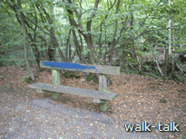
We ignore all footpaths and benches to right or left until we come up to our familiar bench with blue paint on its left back. We are at point 6 and we want to go right.

Soon we see the timber shelter, now on our right. The track is still wide and firm.

Although we might prefer not to retrace our steps at all, I find that coming from the opposite direction, I notice different things

The track curves markedly to the left but the fence and well made track leave us in no doubt of the way to go. The track curves left and then we see our blue-and–white splashed bench ahead and on our left. We are at point 5 on our walk: we have been following the joined butterfly and purple tracks but now we continue on the butterfly-only trail through the double-barred, offset fences.

We pass a deep indentation and a fence corner. The track slopes down gently then steeply and on to boards over the watercourse.
There is a footpath waymark on a low post directing us: unnecessary but reassuring.
The path wiggles and we are off and then on to boards again.

When we come off the boards, the line of the path is not clear. We go up a bit and left a bit and look out for a splodge of paint on a pine.

We bear left and see at last a butterfly waymark. It points us right. We are soon again on to boards which take us over a streamlet. When we come off the boards there is only a yellow arrow on a tree to point us left but this time
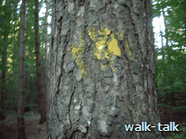
the path ahead is clear.

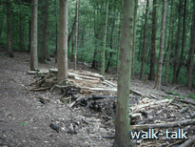
Then we see our pile of timber, this time on our right, and know to be alert.

We take the path butterfly-signed to the LEFT. We go through trees at first and only then on to boards.

Then we go on to the boards with a post numbered 5, on up to Pembridge Lane (point 4 on our walk), across the road to the sign a little to our left, across the board-bridge, by the blackthorn into the meadow, through the kissing gate and left, leaving the duck holiday camp well to the right, making for the next kissing gate set into the hedge, over more boards, angling right to the next kissing gate, and on to the corner with the hidden kissing gate.

We are at point 3 on our walk, the point where butterfly trails merge (on the way up, we said "diverged").

We come out into the next meadow, and head for the next kissing gate. The kissing gate fafter that is the one in amongst tall trees.

We go through the trees and over the boards, across White Stubbs Lane (point 2 on our walk),
and a little way into West End Lane, then in to Emanuel Pollards at the butterfly waymark on the left.

We turn right at the Emanuel Pollards sign, and go through the delicate hornbeam woods.

As the path slopes down and curves right, away from the edge of the wood on the left, we look out for the wooden sign to The Woodman, and the kissing gate under the hornbeam with a distinctive loop in its branches.

We go through the kissing gate and out into the meadow with an excellent far view across the valley ahead and beyond. We walk on between the line of trees on our right and the fence and meadow on the left. We go over the stile and along the path between young pine trees and distorted old hornbeams, out on to the road and across to The Woodman.

We are back at point 1 on our walk, The Woodman.

